1. Create a pod using run command
$ kubectl run <pod-name> --image=<image-name> --port=<container-port>
$ kubectl run my-pod --image=nginx --port=80

2. View all the pods
(In default namespace)
$ kubectl get pods
(In All namespace)

$ kubectl get pods -A
# For a specific namespace
$ kubectl get pods -n kube-system

# For a specific type
$ kubectl get pods <pod-name>
$ kubectl get pods <pod-name> -o wide
$ kubectl get pods <pod-name> -o yaml
$ kubectl get pods <pod-name> -o json

3. Describe a pod (View Pod details)
$ kubectl describe pod <pod-name>
$ kubectl describe pod my-pod
4. View Logs of a pod
$ kubectl logs <pod-name>
$ kubectl logs my-pod
5. Execute any command inside Pod (Inside Pod OS)
$ kubectl exec <pod-name> -- <command>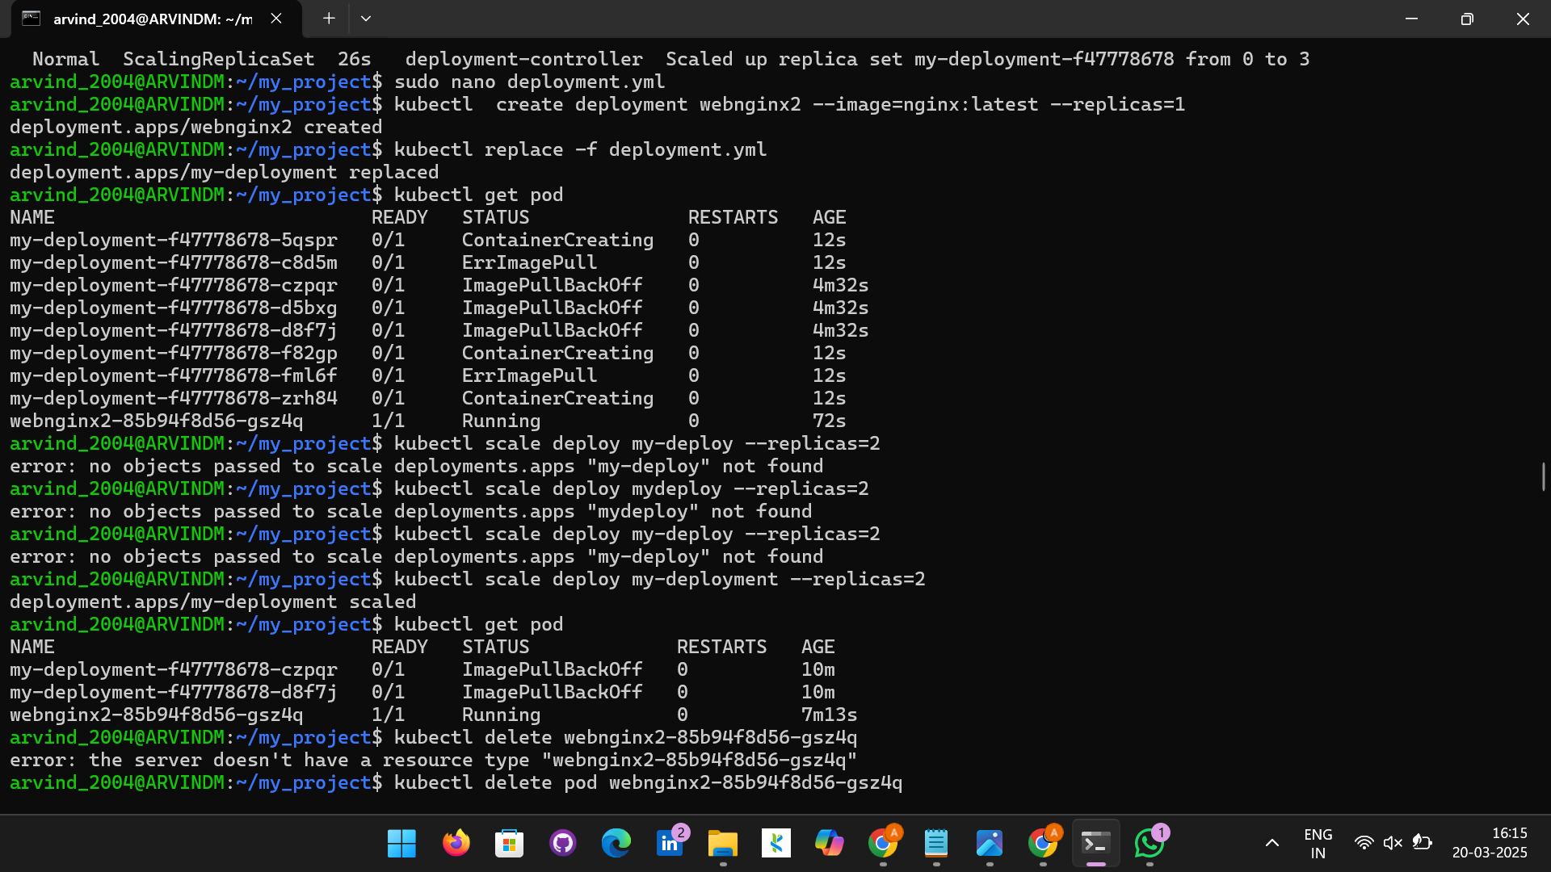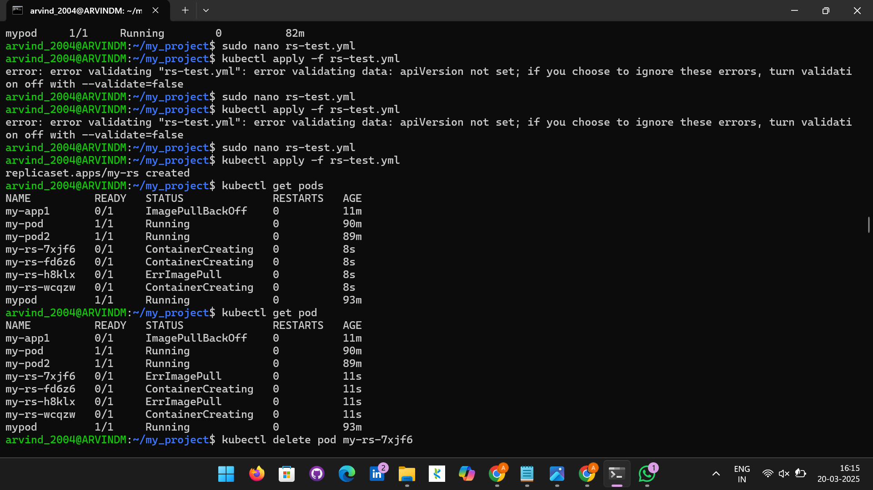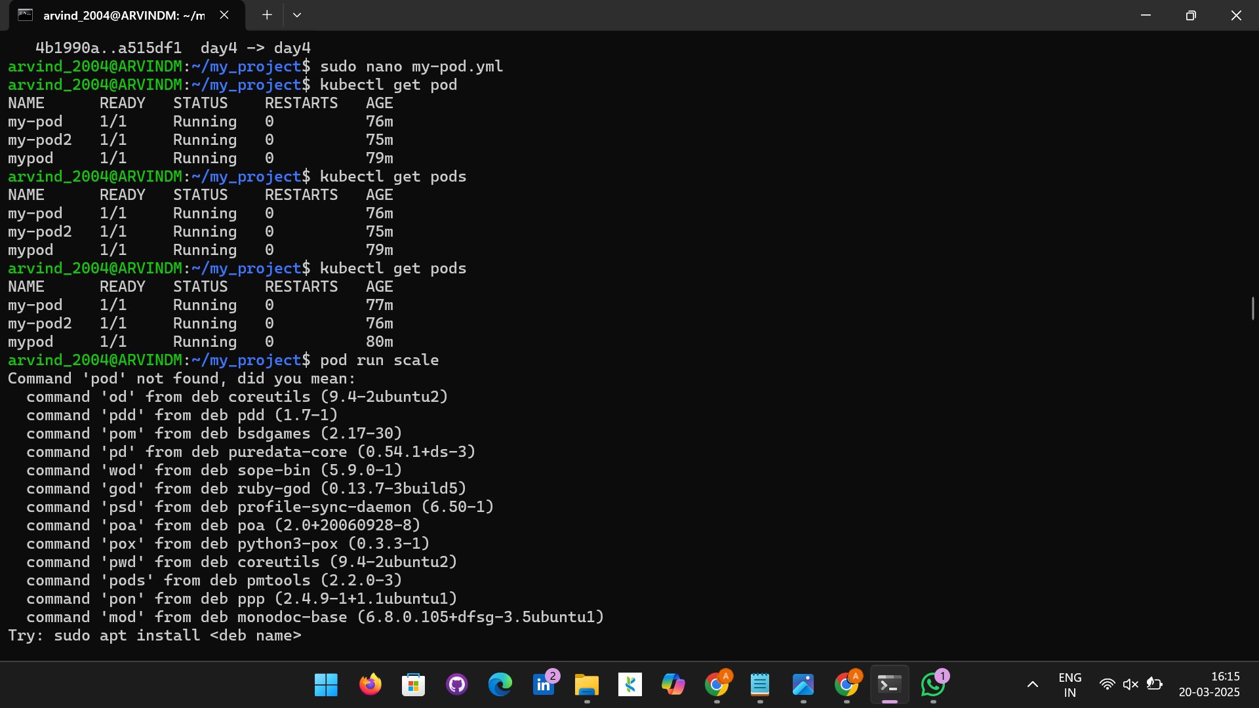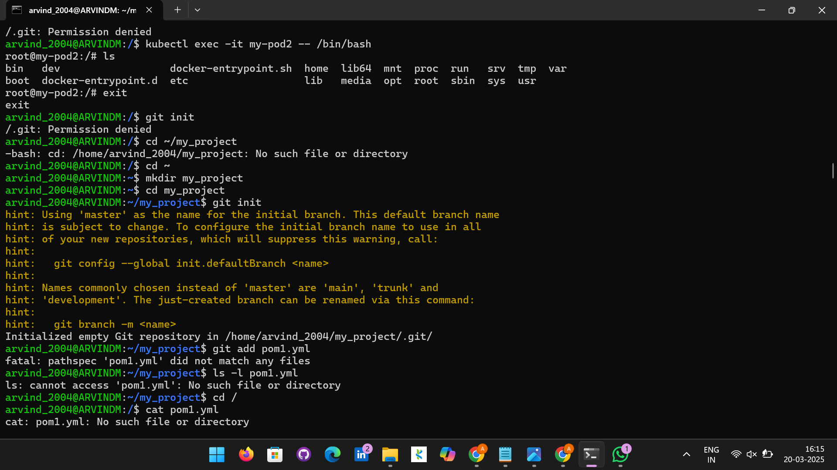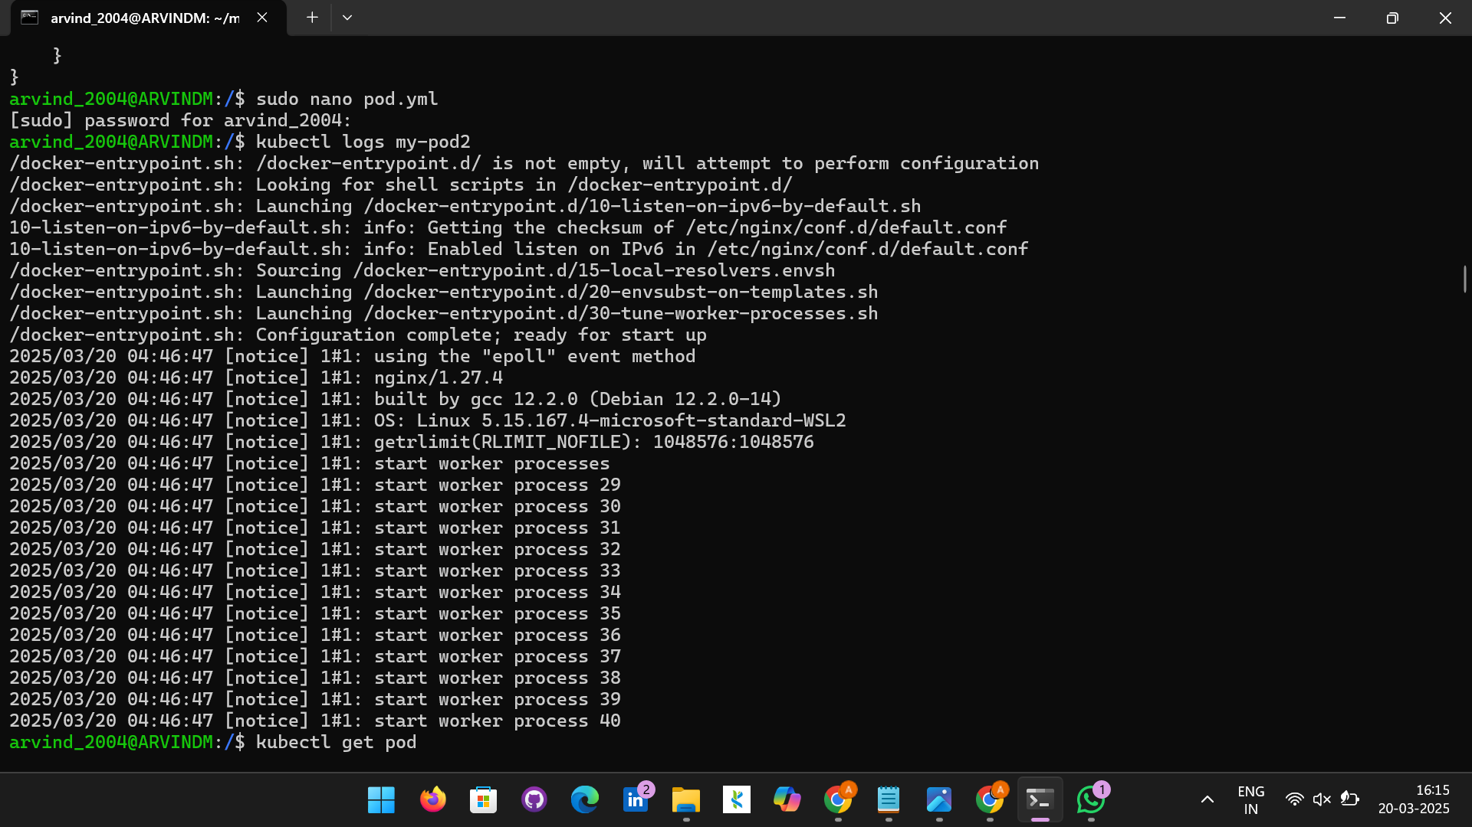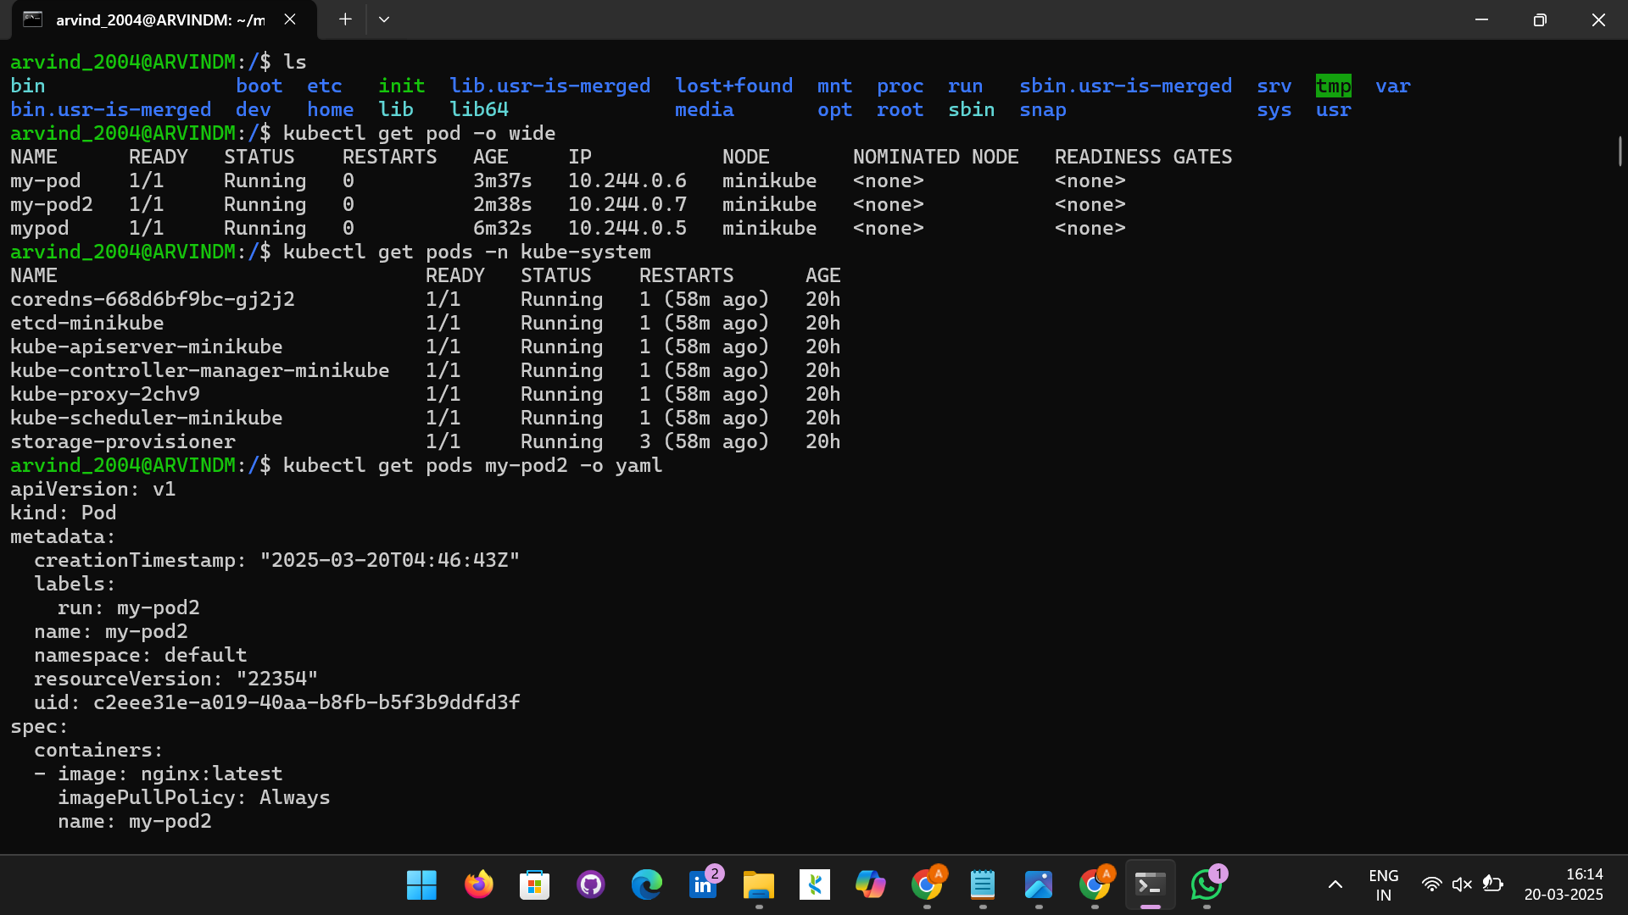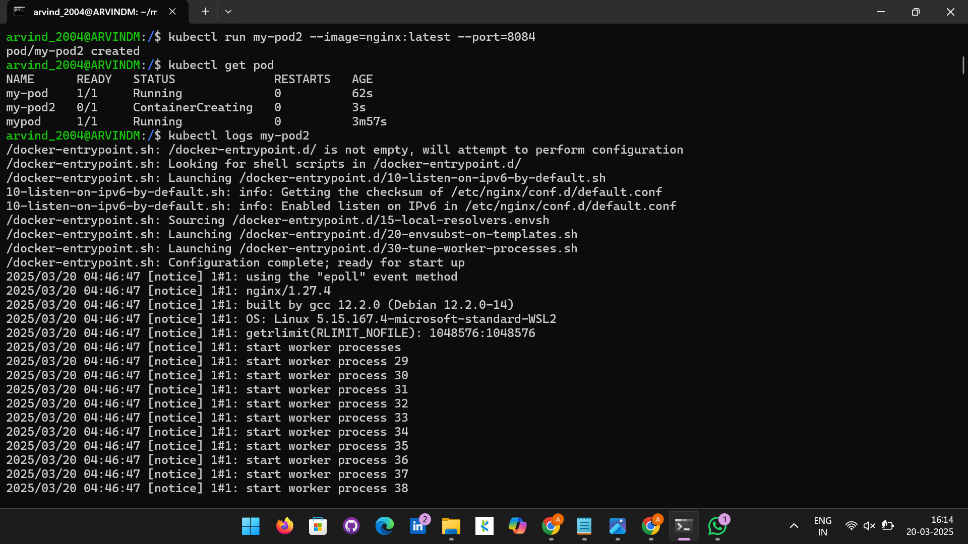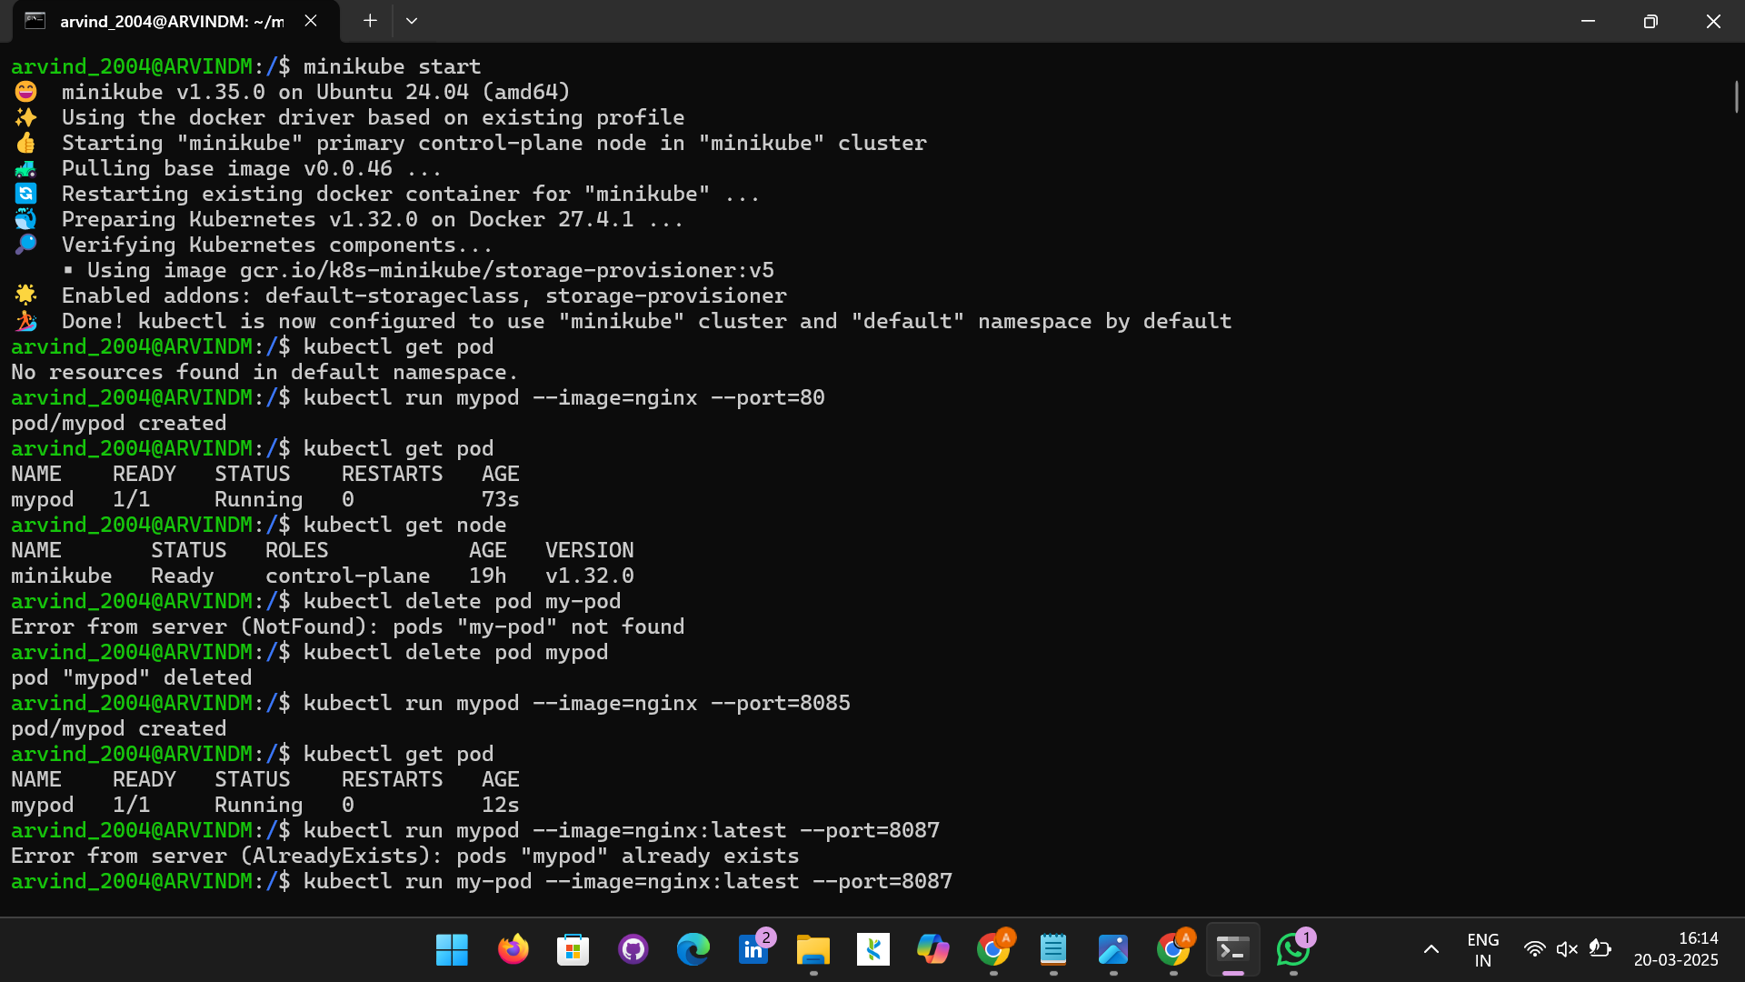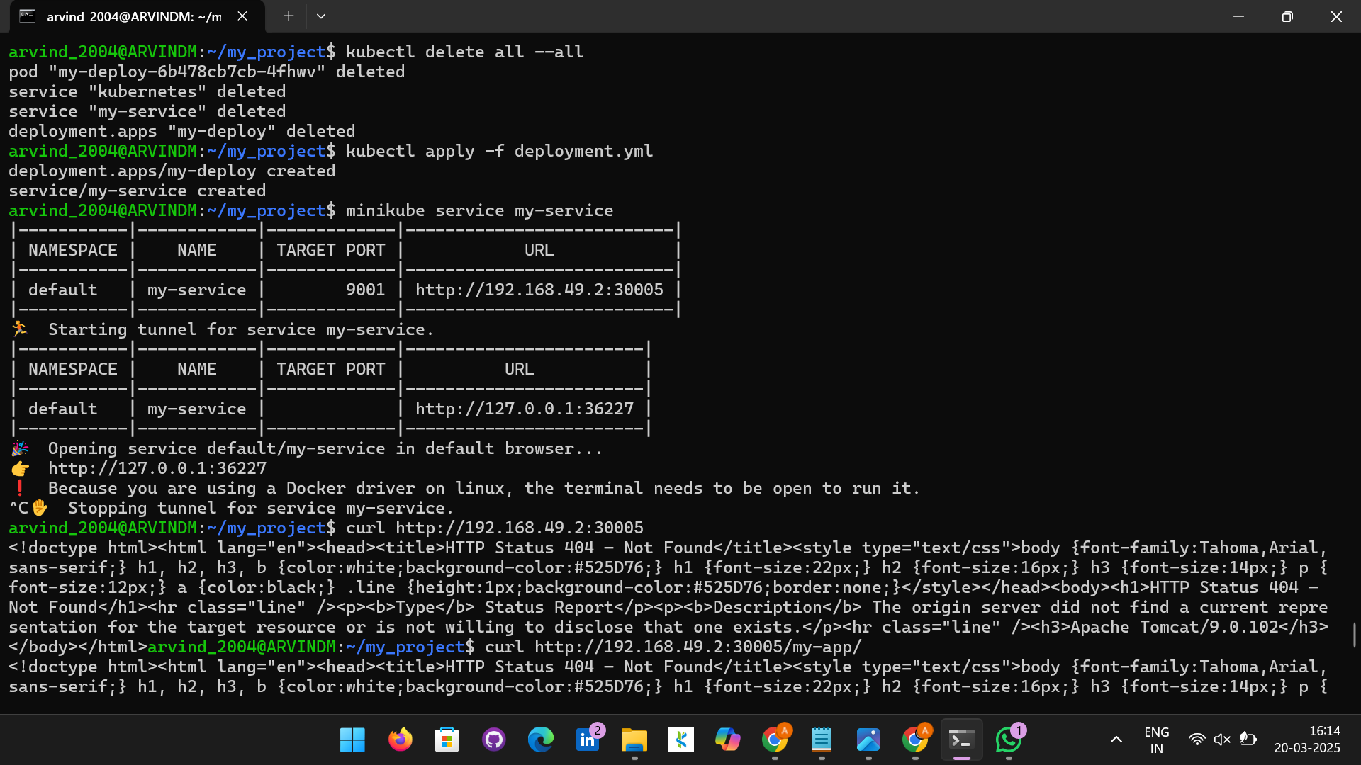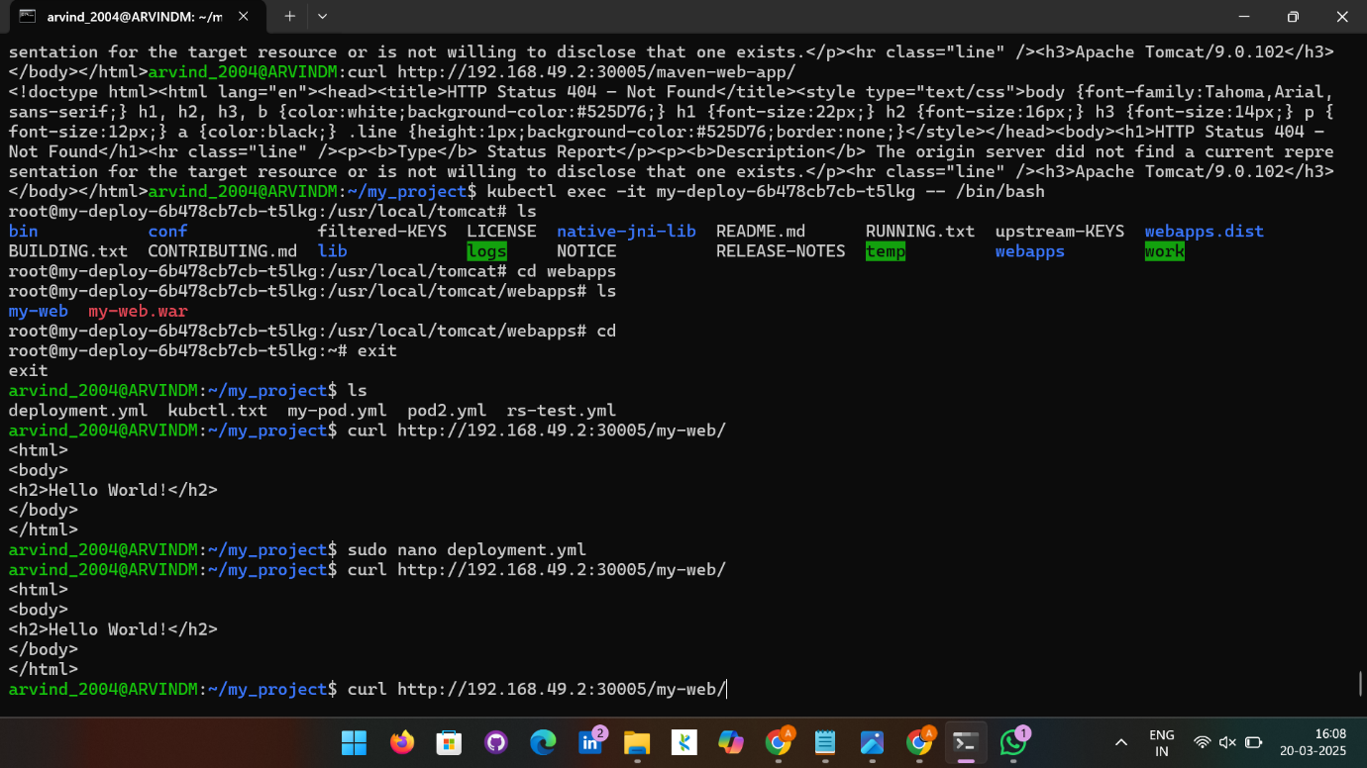 Microsoft Windows [Version 10.0.22631.4751]
(c) Microsoft Corporation. All rights reserved.

C:\Users\Arvind M>wsl.exe -d Ubuntu
Welcome to Ubuntu 24.04.2 LTS (GNU/Linux 5.15.167.4-microsoft-standard-WSL2 x86_64)

* Documentation: https://help.ubuntu.com
* Management: https://landscape.canonical.com
* Support: https://ubuntu.com/pro

System information as of Thu Mar 20 04:31:21 UTC 2025

System load: 0.83 Processes: 36
Usage of /: 0.8% of 1006.85GB Users logged in: 0
Memory usage: 12% IPv4 address for eth0: 172.27.90.197
Swap usage: 0%

This message is shown once a day. To disable it please create the
/home/arvind_2004/.hushlogin file.
arvind_2004@ARVINDM:/mnt/c/Users/Arvind M$ cd ..
arvind_2004@ARVINDM:/mnt/c/Users$ cd /
arvind_2004@ARVINDM:/$ minikube start
😄 minikube v1.35.0 on Ubuntu 24.04 (amd64)
✨ Using the docker driver based on existing profile
👍 Starting "minikube" primary control-plane node in "minikube" cluster
🚜 Pulling base image v0.0.46 ...
🔄 Restarting existing docker container for "minikube" ...
🐳 Preparing Kubernetes v1.32.0 on Docker 27.4.1 ...
🔎 Verifying Kubernetes components...
▪ Using image gcr.io/k8s-minikube/storage-provisioner:v5
🌟 Enabled addons: default-storageclass, storage-provisioner
🏄 Done! kubectl is now configured to use "minikube" cluster and "default" namespace by default
arvind_2004@ARVINDM:/$ kubectl get pod
No resources found in default namespace.
arvind_2004@ARVINDM:/$ kubectl run mypod --image=nginx --port=80
pod/mypod created
arvind_2004@ARVINDM:/$ kubectl get pod
NAME READY STATUS RESTARTS AGE
mypod 1/1 Running 0 73s
arvind_2004@ARVINDM:/$ kubectl get node
NAME STATUS ROLES AGE VERSION
minikube Ready control-plane 19h v1.32.0
arvind_2004@ARVINDM:/$ kubectl delete pod my-pod
Error from server (NotFound): pods "my-pod" not found
arvind_2004@ARVINDM:/$ kubectl delete pod mypod
pod "mypod" deleted
arvind_2004@ARVINDM:/$ kubectl run mypod --image=nginx --port=8085
pod/mypod created
arvind_2004@ARVINDM:/$ kubectl get pod
NAME READY STATUS RESTARTS AGE
mypod 1/1 Running 0 12s
arvind_2004@ARVINDM:/$ kubectl run mypod --image=nginx:latest --port=8087
Error from server (AlreadyExists): pods "mypod" already exists
arvind_2004@ARVINDM:/$ kubectl run my-pod --image=nginx:latest --port=8087
pod/my-pod created
arvind_2004@ARVINDM:/$ kubectl get pod
NAME READY STATUS RESTARTS AGE
my-pod 1/1 Running 0 8s
mypod 1/1 Running 0 3m3s
arvind_2004@ARVINDM:/$ kubectl run my-pod2 --image=nginx:latest --port=8084
pod/my-pod2 created
arvind_2004@ARVINDM:/$ kubectl get pod
NAME READY STATUS RESTARTS AGE
my-pod 1/1 Running 0 62s
my-pod2 0/1 ContainerCreating 0 3s
mypod 1/1 Running 0 3m57s
arvind_2004@ARVINDM:/$ kubectl logs my-pod2
/docker-entrypoint.sh: /docker-entrypoint.d/ is not empty, will attempt to perform configuration
/docker-entrypoint.sh: Looking for shell scripts in /docker-entrypoint.d/
/docker-entrypoint.sh: Launching /docker-entrypoint.d/10-listen-on-ipv6-by-default.sh
10-listen-on-ipv6-by-default.sh: info: Getting the checksum of /etc/nginx/conf.d/default.conf
10-listen-on-ipv6-by-default.sh: info: Enabled listen on IPv6 in /etc/nginx/conf.d/default.conf
/docker-entrypoint.sh: Sourcing /docker-entrypoint.d/15-local-resolvers.envsh
/docker-entrypoint.sh: Launching /docker-entrypoint.d/20-envsubst-on-templates.sh
/docker-entrypoint.sh: Launching /docker-entrypoint.d/30-tune-worker-processes.sh
/docker-entrypoint.sh: Configuration complete; ready for start up
2025/03/20 04:46:47 [notice] 1#1: using the "epoll" event method
2025/03/20 04:46:47 [notice] 1#1: nginx/1.27.4
2025/03/20 04:46:47 [notice] 1#1: built by gcc 12.2.0 (Debian 12.2.0-14)
2025/03/20 04:46:47 [notice] 1#1: OS: Linux 5.15.167.4-microsoft-standard-WSL2
2025/03/20 04:46:47 [notice] 1#1: getrlimit(RLIMIT_NOFILE): 1048576:1048576
2025/03/20 04:46:47 [notice] 1#1: start worker processes
2025/03/20 04:46:47 [notice] 1#1: start worker process 29
2025/03/20 04:46:47 [notice] 1#1: start worker process 30
2025/03/20 04:46:47 [notice] 1#1: start worker process 31
2025/03/20 04:46:47 [notice] 1#1: start worker process 32
2025/03/20 04:46:47 [notice] 1#1: start worker process 33
2025/03/20 04:46:47 [notice] 1#1: start worker process 34
2025/03/20 04:46:47 [notice] 1#1: start worker process 35
2025/03/20 04:46:47 [notice] 1#1: start worker process 36
2025/03/20 04:46:47 [notice] 1#1: start worker process 37
2025/03/20 04:46:47 [notice] 1#1: start worker process 38
2025/03/20 04:46:47 [notice] 1#1: start worker process 39
2025/03/20 04:46:47 [notice] 1#1: start worker process 40
arvind_2004@ARVINDM:/$ minikube ssh
docker@minikube:~$ docker ps
CONTAINER ID IMAGE COMMAND CREATED STATUS PORTS NAMES
2c3ef2e4ea91 nginx "/docker-entrypoint.…" About a minute ago Up About a minute k8s_my-pod2_my-pod2_default_c2eee31e-a019-40aa-b8fb-b5f3b9ddfd3f_0
3c85de85a4ac registry.k8s.io/pause:3.10 "/pause" About a minute ago Up About a minute k8s_POD_my-pod2_default_c2eee31e-a019-40aa-b8fb-b5f3b9ddfd3f_0
18fefc6bc8ad nginx "/docker-entrypoint.…" 2 minutes ago Up 2 minutes k8s_my-pod_my-pod_default_c76700d2-2a03-4cd2-8887-9adc28ee0e72_0
1961b345922d registry.k8s.io/pause:3.10 "/pause" 2 minutes ago Up 2 minutes k8s_POD_my-pod_default_c76700d2-2a03-4cd2-8887-9adc28ee0e72_0
43ca4ffd4f14 nginx "/docker-entrypoint.…" 5 minutes ago Up 5 minutes k8s_mypod_mypod_default_8671366b-5ac7-4c55-9a4a-40a746680ba7_0
a81a4eab7452 registry.k8s.io/pause:3.10 "/pause" 5 minutes ago Up 5 minutes k8s_POD_mypod_default_8671366b-5ac7-4c55-9a4a-40a746680ba7_0
68039fa229f4 6e38f40d628d "/storage-provisioner" 16 minutes ago Up 16 minutes k8s_storage-provisioner_storage-provisioner_kube-system_662c7ba5-f633-49b7-8f08-8fe775a520ee_3
c2f36b460128 c69fa2e9cbf5 "/coredns -conf /etc…" 16 minutes ago Up 16 minutes k8s_coredns_coredns-668d6bf9bc-gj2j2_kube-system_7bfcff89-694f-406a-808e-466d0d549ea8_1
20035d5be14e 040f9f8aac8c "/usr/local/bin/kube…" 16 minutes ago Up 16 minutes k8s_kube-proxy_kube-proxy-2chv9_kube-system_b55c713f-8f1e-4218-b286-07528e7c34ca_1
45f42d177058 registry.k8s.io/pause:3.10 "/pause" 16 minutes ago Up 16 minutes k8s_POD_coredns-668d6bf9bc-gj2j2_kube-system_7bfcff89-694f-406a-808e-466d0d549ea8_1
1124f740e47b registry.k8s.io/pause:3.10 "/pause" 16 minutes ago Up 16 minutes k8s_POD_storage-provisioner_kube-system_662c7ba5-f633-49b7-8f08-8fe775a520ee_1
3bb28a2ca964 registry.k8s.io/pause:3.10 "/pause" 16 minutes ago Up 16 minutes k8s_POD_kube-proxy-2chv9_kube-system_b55c713f-8f1e-4218-b286-07528e7c34ca_1
13ad1eb82586 a9e7e6b294ba "etcd --advertise-cl…" 16 minutes ago Up 16 minutes k8s_etcd_etcd-minikube_kube-system_2b4b75c2a289008e0b381891e9683040_1
9c99aea7da36 c2e17b8d0f4a "kube-apiserver --ad…" 16 minutes ago Up 16 minutes k8s_kube-apiserver_kube-apiserver-minikube_kube-system_d72d0a4cf4be077c9919d46b7358a5e8_1
09bb410b3d82 8cab3d2a8bd0 "kube-controller-man…" 16 minutes ago Up 16 minutes k8s_kube-controller-manager_kube-controller-manager-minikube_kube-system_843c74f7b3bc7d7040a05c31708a6a30_1
cae7502e8a41 a389e107f4ff "kube-scheduler --au…" 16 minutes ago Up 16 minutes k8s_kube-scheduler_kube-scheduler-minikube_kube-system_d14ce008bee3a1f3bd7cf547688f9dfe_1
80138199261a registry.k8s.io/pause:3.10 "/pause" 16 minutes ago Up 16 minutes k8s_POD_kube-apiserver-minikube_kube-system_d72d0a4cf4be077c9919d46b7358a5e8_1
a0e780589b00 registry.k8s.io/pause:3.10 "/pause" 16 minutes ago Up 16 minutes k8s_POD_etcd-minikube_kube-system_2b4b75c2a289008e0b381891e9683040_1
4acf7db67313 registry.k8s.io/pause:3.10 "/pause" 16 minutes ago Up 16 minutes k8s_POD_kube-controller-manager-minikube_kube-system_843c74f7b3bc7d7040a05c31708a6a30_1
a00a5c570e77 registry.k8s.io/pause:3.10 "/pause" 16 minutes ago Up 16 minutes k8s_POD_kube-scheduler-minikube_kube-system_d14ce008bee3a1f3bd7cf547688f9dfe_1
docker@minikube:~$ exit
logout
arvind_2004@ARVINDM:/$ ls
bin boot etc init lib.usr-is-merged lost+found mnt proc run sbin.usr-is-merged srv tmp var
bin.usr-is-merged dev home lib lib64 media opt root sbin snap sys usr
arvind_2004@ARVINDM:/$ kubectl get pod -o wide
NAME READY STATUS RESTARTS AGE IP NODE NOMINATED NODE READINESS GATES
my-pod 1/1 Running 0 3m37s 10.244.0.6 minikube <none> <none>
my-pod2 1/1 Running 0 2m38s 10.244.0.7 minikube <none> <none>
mypod 1/1 Running 0 6m32s 10.244.0.5 minikube <none> <none>
arvind_2004@ARVINDM:/$ kubectl get pods -n kube-system
NAME READY STATUS RESTARTS AGE
coredns-668d6bf9bc-gj2j2 1/1 Running 1 (58m ago) 20h
etcd-minikube 1/1 Running 1 (58m ago) 20h
kube-apiserver-minikube 1/1 Running 1 (58m ago) 20h
kube-controller-manager-minikube 1/1 Running 1 (58m ago) 20h
kube-proxy-2chv9 1/1 Running 1 (58m ago) 20h
kube-scheduler-minikube 1/1 Running 1 (58m ago) 20h
storage-provisioner 1/1 Running 3 (58m ago) 20h
arvind_2004@ARVINDM:/$ kubectl get pods my-pod2 -o yaml
apiVersion: v1
kind: Pod
metadata:
creationTimestamp: "2025-03-20T04:46:43Z"
labels:
run: my-pod2
name: my-pod2
namespace: default
resourceVersion: "22354"
uid: c2eee31e-a019-40aa-b8fb-b5f3b9ddfd3f
spec:
containers:
- image: nginx:latest
imagePullPolicy: Always
name: my-pod2
ports:
- containerPort: 8084
protocol: TCP
resources: {}
terminationMessagePath: /dev/termination-log
terminationMessagePolicy: File
volumeMounts:
- mountPath: /var/run/secrets/kubernetes.io/serviceaccount
name: kube-api-access-ff8h2
readOnly: true
dnsPolicy: ClusterFirst
enableServiceLinks: true
nodeName: minikube
preemptionPolicy: PreemptLowerPriority
priority: 0
restartPolicy: Always
schedulerName: default-scheduler
securityContext: {}
serviceAccount: default
serviceAccountName: default
terminationGracePeriodSeconds: 30
tolerations:
- effect: NoExecute
key: node.kubernetes.io/not-ready
operator: Exists
tolerationSeconds: 300
- effect: NoExecute
key: node.kubernetes.io/unreachable
operator: Exists
tolerationSeconds: 300
volumes:
- name: kube-api-access-ff8h2
projected:
defaultMode: 420
sources:
- serviceAccountToken:
expirationSeconds: 3607
path: token
- configMap:
items:
- key: ca.crt
path: ca.crt
name: kube-root-ca.crt
- downwardAPI:
items:
- fieldRef:
apiVersion: v1
fieldPath: metadata.namespace
path: namespace
status:
conditions:
- lastProbeTime: null
lastTransitionTime: "2025-03-20T04:46:47Z"
status: "True"
type: PodReadyToStartContainers
- lastProbeTime: null
lastTransitionTime: "2025-03-20T04:46:43Z"
status: "True"
type: Initialized
- lastProbeTime: null
lastTransitionTime: "2025-03-20T04:46:47Z"
status: "True"
type: Ready
- lastProbeTime: null
lastTransitionTime: "2025-03-20T04:46:47Z"
status: "True"
type: ContainersReady
- lastProbeTime: null
lastTransitionTime: "2025-03-20T04:46:43Z"
status: "True"
type: PodScheduled
containerStatuses:
- containerID: docker://2c3ef2e4ea91dddd6ada681eab9430a4888c1c17351df593c32dd7ada2f8c06b
image: nginx:latest
imageID: docker-pullable://nginx@sha256:124b44bfc9ccd1f3cedf4b592d4d1e8bddb78b51ec2ed5056c52d3692baebc19
lastState: {}
name: my-pod2
ready: true
restartCount: 0
started: true
state:
running:
startedAt: "2025-03-20T04:46:47Z"
volumeMounts:
- mountPath: /var/run/secrets/kubernetes.io/serviceaccount
name: kube-api-access-ff8h2
readOnly: true
recursiveReadOnly: Disabled
hostIP: 192.168.49.2
hostIPs:
- ip: 192.168.49.2
phase: Running
podIP: 10.244.0.7
podIPs:
- ip: 10.244.0.7
qosClass: BestEffort
startTime: "2025-03-20T04:46:43Z"
arvind_2004@ARVINDM:/$ kubectl get pods my-pod2 -o json
{
"apiVersion": "v1",
"kind": "Pod",
"metadata": {
"creationTimestamp": "2025-03-20T04:46:43Z",
"labels": {
"run": "my-pod2"
},
"name": "my-pod2",
"namespace": "default",
"resourceVersion": "22354",
"uid": "c2eee31e-a019-40aa-b8fb-b5f3b9ddfd3f"
},
"spec": {
"containers": [
{
"image": "nginx:latest",
"imagePullPolicy": "Always",
"name": "my-pod2",
"ports": [
{
"containerPort": 8084,
"protocol": "TCP"
}
],
"resources": {},
"terminationMessagePath": "/dev/termination-log",
"terminationMessagePolicy": "File",
"volumeMounts": [
{
"mountPath": "/var/run/secrets/kubernetes.io/serviceaccount",
"name": "kube-api-access-ff8h2",
"readOnly": true
}
]
}
],
"dnsPolicy": "ClusterFirst",
"enableServiceLinks": true,
"nodeName": "minikube",
"preemptionPolicy": "PreemptLowerPriority",
"priority": 0,
"restartPolicy": "Always",
"schedulerName": "default-scheduler",
"securityContext": {},
"serviceAccount": "default",
"serviceAccountName": "default",
"terminationGracePeriodSeconds": 30,
"tolerations": [
{
"effect": "NoExecute",
"key": "node.kubernetes.io/not-ready",
"operator": "Exists",
"tolerationSeconds": 300
},
{
"effect": "NoExecute",
"key": "node.kubernetes.io/unreachable",
"operator": "Exists",
"tolerationSeconds": 300
}
],
"volumes": [
{
"name": "kube-api-access-ff8h2",
"projected": {
"defaultMode": 420,
"sources": [
{
"serviceAccountToken": {
"expirationSeconds": 3607,
"path": "token"
}
},
{
"configMap": {
"items": [
{
"key": "ca.crt",
"path": "ca.crt"
}
],
"name": "kube-root-ca.crt"
}
},
{
"downwardAPI": {
"items": [
{
"fieldRef": {
"apiVersion": "v1",
"fieldPath": "metadata.namespace"
},
"path": "namespace"
}
]
}
}
]
}
}
]
},
"status": {
"conditions": [
{
"lastProbeTime": null,
"lastTransitionTime": "2025-03-20T04:46:47Z",
"status": "True",
"type": "PodReadyToStartContainers"
},
{
"lastProbeTime": null,
"lastTransitionTime": "2025-03-20T04:46:43Z",
"status": "True",
"type": "Initialized"
},
{
"lastProbeTime": null,
"lastTransitionTime": "2025-03-20T04:46:47Z",
"status": "True",
"type": "Ready"
},
{
"lastProbeTime": null,
"lastTransitionTime": "2025-03-20T04:46:47Z",
"status": "True",
"type": "ContainersReady"
},
{
"lastProbeTime": null,
"lastTransitionTime": "2025-03-20T04:46:43Z",
"status": "True",
"type": "PodScheduled"
}
],
"containerStatuses": [
{
"containerID": "docker://2c3ef2e4ea91dddd6ada681eab9430a4888c1c17351df593c32dd7ada2f8c06b",
"image": "nginx:latest",
"imageID": "docker-pullable://nginx@sha256:124b44bfc9ccd1f3cedf4b592d4d1e8bddb78b51ec2ed5056c52d3692baebc19",
"lastState": {},
"name": "my-pod2",
"ready": true,
"restartCount": 0,
"started": true,
"state": {
"running": {
"startedAt": "2025-03-20T04:46:47Z"
}
},
"volumeMounts": [
{
"mountPath": "/var/run/secrets/kubernetes.io/serviceaccount",
"name": "kube-api-access-ff8h2",
"readOnly": true,
"recursiveReadOnly": "Disabled"
}
]
}
],
"hostIP": "192.168.49.2",
"hostIPs": [
{
"ip": "192.168.49.2"
}
],
"phase": "Running",
"podIP": "10.244.0.7",
"podIPs": [
{
"ip": "10.244.0.7"
}
],
"qosClass": "BestEffort",
"startTime": "2025-03-20T04:46:43Z"
}
}
arvind_2004@ARVINDM:/$ sudo nano pod.yml
[sudo] password for arvind_2004:
arvind_2004@ARVINDM:/$ kubectl logs my-pod2
/docker-entrypoint.sh: /docker-entrypoint.d/ is not empty, will attempt to perform configuration
/docker-entrypoint.sh: Looking for shell scripts in /docker-entrypoint.d/
/docker-entrypoint.sh: Launching /docker-entrypoint.d/10-listen-on-ipv6-by-default.sh
10-listen-on-ipv6-by-default.sh: info: Getting the checksum of /etc/nginx/conf.d/default.conf
10-listen-on-ipv6-by-default.sh: info: Enabled listen on IPv6 in /etc/nginx/conf.d/default.conf
/docker-entrypoint.sh: Sourcing /docker-entrypoint.d/15-local-resolvers.envsh
/docker-entrypoint.sh: Launching /docker-entrypoint.d/20-envsubst-on-templates.sh
/docker-entrypoint.sh: Launching /docker-entrypoint.d/30-tune-worker-processes.sh
/docker-entrypoint.sh: Configuration complete; ready for start up
2025/03/20 04:46:47 [notice] 1#1: using the "epoll" event method
2025/03/20 04:46:47 [notice] 1#1: nginx/1.27.4
2025/03/20 04:46:47 [notice] 1#1: built by gcc 12.2.0 (Debian 12.2.0-14)
2025/03/20 04:46:47 [notice] 1#1: OS: Linux 5.15.167.4-microsoft-standard-WSL2
2025/03/20 04:46:47 [notice] 1#1: getrlimit(RLIMIT_NOFILE): 1048576:1048576
2025/03/20 04:46:47 [notice] 1#1: start worker processes
2025/03/20 04:46:47 [notice] 1#1: start worker process 29
2025/03/20 04:46:47 [notice] 1#1: start worker process 30
2025/03/20 04:46:47 [notice] 1#1: start worker process 31
2025/03/20 04:46:47 [notice] 1#1: start worker process 32
2025/03/20 04:46:47 [notice] 1#1: start worker process 33
2025/03/20 04:46:47 [notice] 1#1: start worker process 34
2025/03/20 04:46:47 [notice] 1#1: start worker process 35
2025/03/20 04:46:47 [notice] 1#1: start worker process 36
2025/03/20 04:46:47 [notice] 1#1: start worker process 37
2025/03/20 04:46:47 [notice] 1#1: start worker process 38
2025/03/20 04:46:47 [notice] 1#1: start worker process 39
2025/03/20 04:46:47 [notice] 1#1: start worker process 40
arvind_2004@ARVINDM:/$ kubectl get pod
NAME READY STATUS RESTARTS AGE
my-pod 1/1 Running 0 54m
my-pod2 1/1 Running 0 53m
mypod 1/1 Running 0 57m
arvind_2004@ARVINDM:/$ sudo nano pod1.yml
arvind_2004@ARVINDM:/$ kubectl get pod
NAME READY STATUS RESTARTS AGE
my-pod 1/1 Running 0 57m
my-pod2 1/1 Running 0 56m
mypod 1/1 Running 0 60m
arvind_2004@ARVINDM:/$ kubectl exec -it my-pod2 -- /bin/bash
root@my-pod2:/# exit
exit
arvind_2004@ARVINDM:/$ git init
/.git: Permission denied
arvind_2004@ARVINDM:/$ kubectl exec -it my-pod2 -- /bin/bash
root@my-pod2:/# ls
bin dev docker-entrypoint.sh home lib64 mnt proc run srv tmp var
boot docker-entrypoint.d etc lib media opt root sbin sys usr
root@my-pod2:/# exit
exit
arvind_2004@ARVINDM:/$ git init
/.git: Permission denied
arvind_2004@ARVINDM:/$ cd ~/my_project
-bash: cd: /home/arvind_2004/my_project: No such file or directory
arvind_2004@ARVINDM:/$ cd ~
arvind_2004@ARVINDM:~$ mkdir my_project
arvind_2004@ARVINDM:~$ cd my_project
arvind_2004@ARVINDM:~/my_project$ git init
hint: Using 'master' as the name for the initial branch. This default branch name
hint: is subject to change. To configure the initial branch name to use in all
hint: of your new repositories, which will suppress this warning, call:
hint:
hint: git config --global init.defaultBranch <name>
hint:
hint: Names commonly chosen instead of 'master' are 'main', 'trunk' and
hint: 'development'. The just-created branch can be renamed via this command:
hint:
hint: git branch -m <name>
Initialized empty Git repository in /home/arvind_2004/my_project/.git/
arvind_2004@ARVINDM:~/my_project$ git add pom1.yml
fatal: pathspec 'pom1.yml' did not match any files
arvind_2004@ARVINDM:~/my_project$ ls -l pom1.yml
ls: cannot access 'pom1.yml': No such file or directory
arvind_2004@ARVINDM:~/my_project$ cd /
arvind_2004@ARVINDM:/$ cat pom1.yml
cat: pom1.yml: No such file or directory
arvind_2004@ARVINDM:/$ cat pod1.yml
apiVersion: v1
kind: Pod
metadata:
name: my-pod2
spec:
containers:
- name: arvindm2004/webapp1
image: arvindm2004/webapp1:tagname
ports:
- containerPort: 8084
arvind_2004@ARVINDM:/$ cd ~/my_project
arvind_2004@ARVINDM:~/my_project$ sudo nano pod2.yml
arvind_2004@ARVINDM:~/my_project$ git init
Reinitialized existing Git repository in /home/arvind_2004/my_project/.git/
arvind_2004@ARVINDM:~/my_project$ git add .
arvind_2004@ARVINDM:~/my_project$ git commit -m "pod"
[master (root-commit) 9e611cd] pod
1 file changed, 10 insertions(+)
create mode 100644 pod2.yml
arvind_2004@ARVINDM:~/my_project$ git remote add origin https://github.com/Arvind22cse/devops_tasks.git
arvind_2004@ARVINDM:~/my_project$ git checkout day4
error: pathspec 'day4' did not match any file(s) known to git
arvind_2004@ARVINDM:~/my_project$ git switch day4
fatal: invalid reference: day4
arvind_2004@ARVINDM:~/my_project$ git branch day4
arvind_2004@ARVINDM:~/my_project$ git checkout day4
Switched to branch 'day4'
arvind_2004@ARVINDM:~/my_project$ git push origin day4
Username for 'https://github.com': Arvind22cse
Password for 'https://Arvind22cse@github.com':
To https://github.com/Arvind22cse/devops_tasks.git
! [rejected] day4 -> day4 (fetch first)
error: failed to push some refs to 'https://github.com/Arvind22cse/devops_tasks.git'
hint: Updates were rejected because the remote contains work that you do not
hint: have locally. This is usually caused by another repository pushing to
hint: the same ref. If you want to integrate the remote changes, use
hint: 'git pull' before pushing again.
hint: See the 'Note about fast-forwards' in 'git push --help' for details.
arvind_2004@ARVINDM:~/my_project$ git pull
remote: Enumerating objects: 29, done.
remote: Counting objects: 100% (29/29), done.
remote: Compressing objects: 100% (27/27), done.
remote: Total 29 (delta 0), reused 29 (delta 0), pack-reused 0 (from 0)
Unpacking objects: 100% (29/29), 3.83 MiB | 2.70 MiB/s, done.
From https://github.com/Arvind22cse/devops_tasks
* [new branch] day1 -> origin/day1
* [new branch] day2 -> origin/day2
* [new branch] day3 -> origin/day3
* [new branch] day4 -> origin/day4
There is no tracking information for the current branch.
Please specify which branch you want to merge with.
See git-pull(1) for details.

git pull <remote> <branch>

If you wish to set tracking information for this branch you can do so with:

git branch --set-upstream-to=origin/<branch> day4

arvind_2004@ARVINDM:~/my_project$ git add .
arvind_2004@ARVINDM:~/my_project$ git commit -m "pod"
On branch day4
nothing to commit, working tree clean
arvind_2004@ARVINDM:~/my_project$ git push origin day4
Username for 'https://github.com': Arvind22cse
Password for 'https://Arvind22cse@github.com':
To https://github.com/Arvind22cse/devops_tasks.git
! [rejected] day4 -> day4 (non-fast-forward)
error: failed to push some refs to 'https://github.com/Arvind22cse/devops_tasks.git'
hint: Updates were rejected because the tip of your current branch is behind
hint: its remote counterpart. If you want to integrate the remote changes,
hint: use 'git pull' before pushing again.
hint: See the 'Note about fast-forwards' in 'git push --help' for details.
arvind_2004@ARVINDM:~/my_project$ git commit -m "pod"
On branch day4
nothing to commit, working tree clean
arvind_2004@ARVINDM:~/my_project$ git push origin day4
Username for 'https://github.com': ^C
arvind_2004@ARVINDM:~/my_project$ git pull --rebase origin day4
From https://github.com/Arvind22cse/devops_tasks
* branch day4 -> FETCH_HEAD
Successfully rebased and updated refs/heads/day4.
arvind_2004@ARVINDM:~/my_project$ git add .
arvind_2004@ARVINDM:~/my_project$ git rebase --continue
fatal: No rebase in progress?
arvind_2004@ARVINDM:~/my_project$ git push origin day4 --force-with-lease
Username for 'https://github.com': Arvind22cse
Password for 'https://Arvind22cse@github.com':
Enumerating objects: 4, done.
Counting objects: 100% (4/4), done.
Delta compression using up to 12 threads
Compressing objects: 100% (3/3), done.
Writing objects: 100% (3/3), 397 bytes | 397.00 KiB/s, done.
Total 3 (delta 0), reused 0 (delta 0), pack-reused 0
To https://github.com/Arvind22cse/devops_tasks.git
4b1990a..a515df1 day4 -> day4
arvind_2004@ARVINDM:~/my_project$ sudo nano my-pod.yml
arvind_2004@ARVINDM:~/my_project$ kubectl get pod
NAME READY STATUS RESTARTS AGE
my-pod 1/1 Running 0 76m
my-pod2 1/1 Running 0 75m
mypod 1/1 Running 0 79m
arvind_2004@ARVINDM:~/my_project$ kubectl get pods
NAME READY STATUS RESTARTS AGE
my-pod 1/1 Running 0 76m
my-pod2 1/1 Running 0 75m
mypod 1/1 Running 0 79m
arvind_2004@ARVINDM:~/my_project$ kubectl get pods
NAME READY STATUS RESTARTS AGE
my-pod 1/1 Running 0 77m
my-pod2 1/1 Running 0 76m
mypod 1/1 Running 0 80m
arvind_2004@ARVINDM:~/my_project$ pod run scale
Command 'pod' not found, did you mean:
command 'od' from deb coreutils (9.4-2ubuntu2)
command 'pdd' from deb pdd (1.7-1)
command 'pom' from deb bsdgames (2.17-30)
command 'pd' from deb puredata-core (0.54.1+ds-3)
command 'wod' from deb sope-bin (5.9.0-1)
command 'god' from deb ruby-god (0.13.7-3build5)
command 'psd' from deb profile-sync-daemon (6.50-1)
command 'poa' from deb poa (2.0+20060928-8)
command 'pox' from deb python3-pox (0.3.3-1)
command 'pwd' from deb coreutils (9.4-2ubuntu2)
command 'pods' from deb pmtools (2.2.0-3)
command 'pon' from deb ppp (2.4.9-1+1.1ubuntu1)
command 'mod' from deb monodoc-base (6.8.0.105+dfsg-3.5ubuntu1)
Try: sudo apt install <deb name>
arvind_2004@ARVINDM:~/my_project$ kubectl apply -f my-pod.yml
pod/my-app1 created
arvind_2004@ARVINDM:~/my_project$ kubectl get pods
NAME READY STATUS RESTARTS AGE
my-app1 0/1 ErrImagePull 0 13s
my-pod 1/1 Running 0 79m
my-pod2 1/1 Running 0 78m
mypod 1/1 Running 0 82m
arvind_2004@ARVINDM:~/my_project$ sudo nano rs-test.yml
arvind_2004@ARVINDM:~/my_project$ kubectl apply -f rs-test.yml
error: error validating "rs-test.yml": error validating data: apiVersion not set; if you choose to ignore these errors, turn validation off with --validate=false
arvind_2004@ARVINDM:~/my_project$ sudo nano rs-test.yml
arvind_2004@ARVINDM:~/my_project$ kubectl apply -f rs-test.yml
error: error validating "rs-test.yml": error validating data: apiVersion not set; if you choose to ignore these errors, turn validation off with --validate=false
arvind_2004@ARVINDM:~/my_project$ sudo nano rs-test.yml
arvind_2004@ARVINDM:~/my_project$ kubectl apply -f rs-test.yml
replicaset.apps/my-rs created
arvind_2004@ARVINDM:~/my_project$ kubectl get pods
NAME READY STATUS RESTARTS AGE
my-app1 0/1 ImagePullBackOff 0 11m
my-pod 1/1 Running 0 90m
my-pod2 1/1 Running 0 89m
my-rs-7xjf6 0/1 ContainerCreating 0 8s
my-rs-fd6z6 0/1 ContainerCreating 0 8s
my-rs-h8klx 0/1 ErrImagePull 0 8s
my-rs-wcqzw 0/1 ContainerCreating 0 8s
mypod 1/1 Running 0 93m
arvind_2004@ARVINDM:~/my_project$ kubectl get pod
NAME READY STATUS RESTARTS AGE
my-app1 0/1 ImagePullBackOff 0 11m
my-pod 1/1 Running 0 90m
my-pod2 1/1 Running 0 89m
my-rs-7xjf6 0/1 ErrImagePull 0 11s
my-rs-fd6z6 0/1 ContainerCreating 0 11s
my-rs-h8klx 0/1 ErrImagePull 0 11s
my-rs-wcqzw 0/1 ContainerCreating 0 11s
mypod 1/1 Running 0 93m
arvind_2004@ARVINDM:~/my_project$ kubectl delete pod my-rs-7xjf6
pod "my-rs-7xjf6" deleted
arvind_2004@ARVINDM:~/my_project$ kubectl get pod
NAME READY STATUS RESTARTS AGE
my-app1 0/1 ImagePullBackOff 0 12m
my-pod 1/1 Running 0 91m
my-pod2 1/1 Running 0 90m
my-rs-ctmbx 0/1 ContainerCreating 0 3s
my-rs-fd6z6 0/1 ImagePullBackOff 0 66s
my-rs-h8klx 0/1 ImagePullBackOff 0 66s
my-rs-wcqzw 0/1 ErrImagePull 0 66s
mypod 1/1 Running 0 94m
arvind_2004@ARVINDM:~/my_project$ kubectl exec -it my-rs-ctmbx -- /bin/bash
error: Internal error occurred: unable to upgrade connection: container not found ("my-app")
arvind_2004@ARVINDM:~/my_project$ kubectl describe my-rs-ctmbx
error: the server doesn't have a resource type "my-rs-ctmbx"
arvind_2004@ARVINDM:~/my_project$ kubectl describe my-rs-fd6z6
error: the server doesn't have a resource type "my-rs-fd6z6"
arvind_2004@ARVINDM:~/my_project$ kubectl get pod
NAME READY STATUS RESTARTS AGE
my-app1 0/1 ImagePullBackOff 0 138m
my-pod 1/1 Running 0 3h37m
my-pod2 1/1 Running 0 3h36m
my-rs-ctmbx 0/1 ImagePullBackOff 0 126m
my-rs-fd6z6 0/1 ImagePullBackOff 0 127m
my-rs-h8klx 0/1 ImagePullBackOff 0 127m
my-rs-wcqzw 0/1 ImagePullBackOff 0 127m
mypod 1/1 Running 0 3h40m
arvind_2004@ARVINDM:~/my_project$ sudo nano deployment.yml
[sudo] password for arvind_2004:
arvind_2004@ARVINDM:~/my_project$
arvind_2004@ARVINDM:~/my_project$ kubectl create deployment webnginx2 --image=nginx:latest --replicas=1
deployment.apps/webnginx2 created
arvind_2004@ARVINDM:~/my_project$ kubectl get pods
NAME READY STATUS RESTARTS AGE
my-app1 0/1 ImagePullBackOff 0 145m
my-pod 1/1 Running 0 3h44m
my-pod2 1/1 Running 0 3h43m
my-rs-ctmbx 0/1 ImagePullBackOff 0 133m
my-rs-fd6z6 0/1 ImagePullBackOff 0 134m
my-rs-h8klx 0/1 ImagePullBackOff 0 134m
my-rs-wcqzw 0/1 ImagePullBackOff 0 134m
mypod 1/1 Running 0 3h47m
webnginx2-85b94f8d56-vgh6b 1/1 Running 0 13s
arvind_2004@ARVINDM:~/my_project$ kubectl get rs
NAME DESIRED CURRENT READY AGE
my-rs 4 4 0 134m
webnginx2-85b94f8d56 1 1 1 46s
arvind_2004@ARVINDM:~/my_project$ kubectl kubectl delete all -all
error: unknown command "kubectl" for "kubectl"
arvind_2004@ARVINDM:~/my_project$ kubect delete all -all
Command 'kubect' not found, did you mean:
command 'kubectx' from deb kubectx (0.9.5-1ubuntu0.3)
Try: sudo apt install <deb name>
arvind_2004@ARVINDM:~/my_project$ kubectl delete all -all
error: unknown shorthand flag: 'a' in -all
See 'kubectl delete --help' for usage.
arvind_2004@ARVINDM:~/my_project$ kubectl delete all --all
pod "my-app1" deleted
pod "my-pod" deleted
pod "my-pod2" deleted
pod "my-rs-ctmbx" deleted
pod "my-rs-fd6z6" deleted
pod "my-rs-h8klx" deleted
pod "my-rs-wcqzw" deleted
pod "mypod" deleted
pod "webnginx2-85b94f8d56-vgh6b" deleted
service "kubernetes" deleted
deployment.apps "webnginx2" deleted
replicaset.apps "my-rs" deleted
replicaset.apps "webnginx2-85b94f8d56" deleted
arvind_2004@ARVINDM:~/my_project$ kubectl get pod
NAME READY STATUS RESTARTS AGE
my-rs-kdzk7 0/1 Terminating 0 26s
my-rs-nnwdc 0/1 Terminating 0 25s
arvind_2004@ARVINDM:~/my_project$ kubectl apply -f deployment.yml
\Error from server (BadRequest): error when creating "deployment.yml": Deployment in version "v1" cannot be handled as a Deployment: json: cannot unmarshal string into Go struct field Container.spec.template.spec.containers.ports of type v1.ContainerPort
arvind_2004@ARVINDM:~/my_project$ kubectl apply -f deployment.yml
Error from server (BadRequest): error when creating "deployment.yml": Deployment in version "v1" cannot be handled as a Deployment: json: cannot unmarshal string into Go struct field Container.spec.template.spec.containers.ports of type v1.ContainerPort
arvind_2004@ARVINDM:~/my_project$ sudo nano deployment.yml
arvind_2004@ARVINDM:~/my_project$ kubectl apply -f deployment.yml
deployment.apps/my-deployment created
arvind_2004@ARVINDM:~/my_project$ kubectl get deployments
NAME READY UP-TO-DATE AVAILABLE AGE
my-deployment 0/3 3 0 8s
arvind_2004@ARVINDM:~/my_project$ kubectl get pods
NAME READY STATUS RESTARTS AGE
my-deployment-f47778678-czpqr 0/1 ErrImagePull 0 18s
my-deployment-f47778678-d5bxg 0/1 ImagePullBackOff 0 18s
my-deployment-f47778678-d8f7j 0/1 ImagePullBackOff 0 18s
arvind_2004@ARVINDM:~/my_project$ kubectl describe deployment my-deployment
Name: my-deployment
Namespace: default
CreationTimestamp: Thu, 20 Mar 2025 08:37:01 +0000
Labels: <none>
Annotations: deployment.kubernetes.io/revision: 1
Selector: app=my-app
Replicas: 3 desired | 3 updated | 3 total | 0 available | 3 unavailable
StrategyType: RollingUpdate
MinReadySeconds: 0
RollingUpdateStrategy: 25% max unavailable, 25% max surge
Pod Template:
Labels: app=my-app
Containers:
my-app:
Image: arvindm2004/webapp1:tagname
Port: 8089/TCP
Host Port: 0/TCP
Environment: <none>
Mounts: <none>
Volumes: <none>
Node-Selectors: <none>
Tolerations: <none>
Conditions:
Type Status Reason
---- ------ ------
Available False MinimumReplicasUnavailable
Progressing True ReplicaSetUpdated
OldReplicaSets: <none>
NewReplicaSet: my-deployment-f47778678 (3/3 replicas created)
Events:
Type Reason Age From Message
---- ------ ---- ---- -------
Normal ScalingReplicaSet 26s deployment-controller Scaled up replica set my-deployment-f47778678 from 0 to 3
arvind_2004@ARVINDM:~/my_project$ sudo nano deployment.yml
arvind_2004@ARVINDM:~/my_project$ kubectl create deployment webnginx2 --image=nginx:latest --replicas=1
deployment.apps/webnginx2 created
arvind_2004@ARVINDM:~/my_project$ kubectl replace -f deployment.yml
deployment.apps/my-deployment replaced
arvind_2004@ARVINDM:~/my_project$ kubectl get pod
NAME READY STATUS RESTARTS AGE
my-deployment-f47778678-5qspr 0/1 ContainerCreating 0 12s
my-deployment-f47778678-c8d5m 0/1 ErrImagePull 0 12s
my-deployment-f47778678-czpqr 0/1 ImagePullBackOff 0 4m32s
my-deployment-f47778678-d5bxg 0/1 ImagePullBackOff 0 4m32s
my-deployment-f47778678-d8f7j 0/1 ImagePullBackOff 0 4m32s
my-deployment-f47778678-f82gp 0/1 ContainerCreating 0 12s
my-deployment-f47778678-fml6f 0/1 ErrImagePull 0 12s
my-deployment-f47778678-zrh84 0/1 ContainerCreating 0 12s
webnginx2-85b94f8d56-gsz4q 1/1 Running 0 72s
arvind_2004@ARVINDM:~/my_project$ kubectl scale deploy my-deploy --replicas=2
error: no objects passed to scale deployments.apps "my-deploy" not found
arvind_2004@ARVINDM:~/my_project$ kubectl scale deploy mydeploy --replicas=2
error: no objects passed to scale deployments.apps "mydeploy" not found
arvind_2004@ARVINDM:~/my_project$ kubectl scale deploy my-deploy --replicas=2
error: no objects passed to scale deployments.apps "my-deploy" not found
arvind_2004@ARVINDM:~/my_project$ kubectl scale deploy my-deployment --replicas=2
deployment.apps/my-deployment scaled
arvind_2004@ARVINDM:~/my_project$ kubectl get pod
NAME READY STATUS RESTARTS AGE
my-deployment-f47778678-czpqr 0/1 ImagePullBackOff 0 10m
my-deployment-f47778678-d8f7j 0/1 ImagePullBackOff 0 10m
webnginx2-85b94f8d56-gsz4q 1/1 Running 0 7m13s
arvind_2004@ARVINDM:~/my_project$ kubectl delete webnginx2-85b94f8d56-gsz4q
error: the server doesn't have a resource type "webnginx2-85b94f8d56-gsz4q"
arvind_2004@ARVINDM:~/my_project$ kubectl delete pod webnginx2-85b94f8d56-gsz4q
pod "webnginx2-85b94f8d56-gsz4q" deleted
arvind_2004@ARVINDM:~/my_project$ kubectl get pod
NAME READY STATUS RESTARTS AGE
my-deployment-f47778678-czpqr 0/1 ImagePullBackOff 0 11m
my-deployment-f47778678-d8f7j 0/1 ImagePullBackOff 0 11m
webnginx2-85b94f8d56-cvxv2 1/1 Running 0 6s
arvind_2004@ARVINDM:~/my_project$ kubectl get pod
NAME READY STATUS RESTARTS AGE
my-deployment-f47778678-czpqr 0/1 ImagePullBackOff 0 11m
my-deployment-f47778678-d8f7j 0/1 ErrImagePull 0 11m
webnginx2-85b94f8d56-cvxv2 1/1 Running 0 10s
arvind_2004@ARVINDM:~/my_project$ kubectl get pod
NAME READY STATUS RESTARTS AGE
my-deployment-f47778678-czpqr 0/1 ImagePullBackOff 0 12m
my-deployment-f47778678-d8f7j 0/1 ImagePullBackOff 0 12m
webnginx2-85b94f8d56-cvxv2 1/1 Running 0 29s
arvind_2004@ARVINDM:~/my_project$ sudo nano deployment.yml
arvind_2004@ARVINDM:~/my_project$ kubectl create apply -f deployment.yml
error: Unexpected args: [apply]
See 'kubectl create -h' for help and examples
arvind_2004@ARVINDM:~/my_project$ kubectl create apply -f deployment.yml
error: Unexpected args: [apply]
See 'kubectl create -h' for help and examples
arvind_2004@ARVINDM:~/my_project$ kubectl apply -f deployment.yml
deployment.apps/my-deploy created
Error from server (BadRequest): error when creating "deployment.yml": Service in version "v1" cannot be handled as a Service: json: cannot unmarshal string into Go struct field ServiceSpec.spec.selector of type map[string]string
arvind_2004@ARVINDM:~/my_project$ cat deployment.yml
apiVersion: apps/v1
kind: Deployment
metadata:
name: my-deploy
labels:
name: my-deploy
spec:
replicas: 1
selector:
matchLabels:
apptype: web-backend
strategy:
type: RollingUpdate
template:
metadata:
labels:
apptype: web-backend
spec:
containers:
- name: my-app
image: arvindm2004/webapp1:tagname
ports:
- containerPort: 7070
---

apiVersion: v1
kind: Service
metadata:
name: my-service
labels:
app: my-service
type: backend-app
spec:
type: NodePort
ports:
- targetPort: 7070
port: 7070
nodePort: 30002
selector:
apptype: web-backend
arvind_2004@ARVINDM:~/my_project$ sudo nano deployment.yml
[sudo] password for arvind_2004:
arvind_2004@ARVINDM:~/my_project$ kubectl apply -f deployment.yml
service/my-service created
arvind_2004@ARVINDM:~/my_project$ kubectl get pods
NAME READY STATUS RESTARTS AGE
my-deploy-5df65497db-xfhlq 0/1 ErrImagePull 0 3m40s
my-deployment-f47778678-czpqr 0/1 ImagePullBackOff 0 41m
my-deployment-f47778678-d8f7j 0/1 ImagePullBackOff 0 41m
webnginx2-85b94f8d56-cvxv2 1/1 Running 0 29m
arvind_2004@ARVINDM:~/my_project$ kubectl get services
NAME TYPE CLUSTER-IP EXTERNAL-IP PORT(S) AGE
kubernetes ClusterIP 10.96.0.1 <none> 443/TCP 44m
my-service NodePort 10.106.84.41 <none> 7070:30002/TCP 31s
arvind_2004@ARVINDM:~/my_project$ sudo nano deployment.yml
[sudo] password for arvind_2004:
arvind_2004@ARVINDM:~/my_project$ kubectl apply -f deployment.yml
deployment.apps/my-deploy configured
service/my-service unchanged
arvind_2004@ARVINDM:~/my_project$ kubectl replace deployment.yml
error: must specify one of -f and -k
arvind_2004@ARVINDM:~/my_project$ kubectl replace -f deployment.yml
deployment.apps/my-deploy replaced
service/my-service replaced
arvind_2004@ARVINDM:~/my_project$ minikube service my-service
|-----------|------------|-------------|---------------------------|
| NAMESPACE | NAME | TARGET PORT | URL |
|-----------|------------|-------------|---------------------------|
| default | my-service | 7070 | http://192.168.49.2:30002 |
|-----------|------------|-------------|---------------------------|

❌ Exiting due to SVC_UNREACHABLE: service not available: no running pod for service my-service found

╭───────────────────────────────────────────────────────────────────────────────────────────╮
│ │
│ 😿 If the above advice does not help, please let us know: │
│ 👉 https://github.com/kubernetes/minikube/issues/new/choose │
│ │
│ Please run `minikube logs --file=logs.txt` and attach logs.txt to the GitHub issue. │
│ Please also attach the following file to the GitHub issue: │
│ - /tmp/minikube_service_8aaa71feca0d33a15dc0b5f1d3de1c519de02edd_0.log │
│ │
╰───────────────────────────────────────────────────────────────────────────────────────────╯

arvind_2004@ARVINDM:~/my_project$ curl http://192.168.49.2:30002
curl: (7) Failed to connect to 192.168.49.2 port 30002 after 1 ms: Couldn't connect to server
arvind_2004@ARVINDM:~/my_project$ ping http://192.168.49.2:30002
ping: http://192.168.49.2:30002: Name or service not known
arvind_2004@ARVINDM:~/my_project$ ping http://192.168.49.2:30002/my-app/
ping: http://192.168.49.2:30002/my-app/: Name or service not known
arvind_2004@ARVINDM:~/my_project$ sudo chmod 666 /var/run/docker.sock
[sudo] password for arvind_2004:
arvind_2004@ARVINDM:~/my_project$ kubectl delete all --all
pod "my-deploy-5df65497db-mv5jq" deleted
pod "my-deploy-5df65497db-n4ln2" deleted
pod "my-deploy-5df65497db-tt8n6" deleted
pod "my-deploy-5df65497db-xfhlq" deleted
pod "my-deployment-f47778678-czpqr" deleted
pod "my-deployment-f47778678-d8f7j" deleted
pod "webnginx2-85b94f8d56-cvxv2" deleted
service "kubernetes" deleted
service "my-service" deleted
deployment.apps "my-deploy" deleted
deployment.apps "my-deployment" deleted
deployment.apps "webnginx2" deleted
replicaset.apps "webnginx2-85b94f8d56" deleted
arvind_2004@ARVINDM:~/my_project$ sudo nano deployment.yml
arvind_2004@ARVINDM:~/my_project$ sudo nano deployment.yml
arvind_2004@ARVINDM:~/my_project$ kubectl apply -f deployment.yml
deployment.apps/my-deploy created
service/my-service created
arvind_2004@ARVINDM:~/my_project$ minikube service myservice.yml

❌ Exiting due to SVC_NOT_FOUND: Service 'myservice.yml' was not found in 'default' namespace.
You may select another namespace by using 'minikube service myservice.yml -n <namespace>'. Or list out all the services using 'minikube service list'

arvind_2004@ARVINDM:~/my_project$ minikube service my-service
|-----------|------------|-------------|---------------------------|
| NAMESPACE | NAME | TARGET PORT | URL |
|-----------|------------|-------------|---------------------------|
| default | my-service | 9000 | http://192.168.49.2:30002 |
|-----------|------------|-------------|---------------------------|

❌ Exiting due to SVC_UNREACHABLE: service not available: no running pod for service my-service found

╭───────────────────────────────────────────────────────────────────────────────────────────╮
│ │
│ 😿 If the above advice does not help, please let us know: │
│ 👉 https://github.com/kubernetes/minikube/issues/new/choose │
│ │
│ Please run `minikube logs --file=logs.txt` and attach logs.txt to the GitHub issue. │
│ Please also attach the following file to the GitHub issue: │
│ - /tmp/minikube_service_8aaa71feca0d33a15dc0b5f1d3de1c519de02edd_0.log │
│ │
╰───────────────────────────────────────────────────────────────────────────────────────────╯

arvind_2004@ARVINDM:~/my_project$ curl http://192.168.49.2:30002
curl: (7) Failed to connect to 192.168.49.2 port 30002 after 0 ms: Couldn't connect to server
arvind_2004@ARVINDM:~/my_project$ cat deployment.yml
apiVersion: apps/v1
kind: Deployment
metadata:
name: my-deploy
labels:
name: my-deploy
spec:
replicas: 4
selector:
matchLabels:
apptype: web-backend
strategy:
type: RollingUpdate
template:
metadata:
labels:
apptype: web-backend
spec:
containers:
- name: my-app
image: arvindm2004/webapp1:tagname
ports:
- containerPort: 9000
---

apiVersion: v1
kind: Service
metadata:
name: my-service
labels:
app: my-service
type: backend-app
spec:
type: NodePort
ports:
- targetPort: 9000
port: 9000
nodePort: 30002
selector:
apptype: web-backend
arvind_2004@ARVINDM:~/my_project$ kubectl get pods
NAME READY STATUS RESTARTS AGE
my-deploy-84f4966d79-64z7p 0/1 ImagePullBackOff 0 4m41s
my-deploy-84f4966d79-7f92t 0/1 ImagePullBackOff 0 4m41s
my-deploy-84f4966d79-bt29f 0/1 ImagePullBackOff 0 4m41s
my-deploy-84f4966d79-n4ts5 0/1 ImagePullBackOff 0 4m41s
arvind_2004@ARVINDM:~/my_project$ kubectl describe deployment my-deploy
Name: my-deploy
Namespace: default
CreationTimestamp: Thu, 20 Mar 2025 10:07:31 +0000
Labels: name=my-deploy
Annotations: deployment.kubernetes.io/revision: 1
Selector: apptype=web-backend
Replicas: 4 desired | 4 updated | 4 total | 0 available | 4 unavailable
StrategyType: RollingUpdate
MinReadySeconds: 0
RollingUpdateStrategy: 25% max unavailable, 25% max surge
Pod Template:
Labels: apptype=web-backend
Containers:
my-app:
Image: arvindm2004/webapp1:tagname
Port: 9000/TCP
Host Port: 0/TCP
Environment: <none>
Mounts: <none>
Volumes: <none>
Node-Selectors: <none>
Tolerations: <none>
Conditions:
Type Status Reason
---- ------ ------
Available False MinimumReplicasUnavailable
Progressing True ReplicaSetUpdated
OldReplicaSets: <none>
NewReplicaSet: my-deploy-84f4966d79 (4/4 replicas created)
Events:
Type Reason Age From Message
---- ------ ---- ---- -------
Normal ScalingReplicaSet 4m54s deployment-controller Scaled up replica set my-deploy-84f4966d79 from 0 to 4
arvind_2004@ARVINDM:~/my_project$ kubectl port-forward service/my-service 9000:9000
error: unable to forward port because pod is not running. Current status=Pending
arvind_2004@ARVINDM:~/my_project$ kubectl delete all --all
pod "my-deploy-84f4966d79-64z7p" deleted
pod "my-deploy-84f4966d79-7f92t" deleted
pod "my-deploy-84f4966d79-bt29f" deleted
pod "my-deploy-84f4966d79-n4ts5" deleted
service "kubernetes" deleted
service "my-service" deleted
deployment.apps "my-deploy" deleted
arvind_2004@ARVINDM:~/my_project$ kubectl delete pods --all
pod "my-deploy-84f4966d79-52xlz" deleted
pod "my-deploy-84f4966d79-rptt5" deleted
arvind_2004@ARVINDM:~/my_project$ kubectl apply -f deployment.yml
deployment.apps/my-deploy created
service/my-service created
arvind_2004@ARVINDM:~/my_project$ kubectl get pods
NAME READY STATUS RESTARTS AGE
my-deploy-84f4966d79-qhtb2 0/1 ContainerCreating 0 9s
my-deploy-84f4966d79-tg7nl 0/1 ContainerCreating 0 9s
my-deploy-84f4966d79-zflkr 0/1 ErrImagePull 0 9s
my-deploy-84f4966d79-zgf99 0/1 ContainerCreating 0 9s
arvind_2004@ARVINDM:~/my_project$ kubectl port-forward service/my-service 9000:9000
error: unable to forward port because pod is not running. Current status=Pending
arvind_2004@ARVINDM:~/my_project$ docker pull arvindm2004/webapp1:tagname
Error response from daemon: manifest for arvindm2004/webapp1:tagname not found: manifest unknown: manifest unknown
arvind_2004@ARVINDM:~/my_project$ sudo nano deployment.yml
arvind_2004@ARVINDM:~/my_project$ kubectl apply -f deployment.yml
deployment.apps/my-deploy configured
error: error parsing deployment.yml: error converting YAML to JSON: yaml: line 15: mapping values are not allowed in this context
arvind_2004@ARVINDM:~/my_project$ minikube service my-service
|-----------|------------|-------------|---------------------------|
| NAMESPACE | NAME | TARGET PORT | URL |
|-----------|------------|-------------|---------------------------|
| default | my-service | 9000 | http://192.168.49.2:30002 |
|-----------|------------|-------------|---------------------------|

❌ Exiting due to SVC_UNREACHABLE: service not available: no running pod for service my-service found

╭───────────────────────────────────────────────────────────────────────────────────────────╮
│ │
│ 😿 If the above advice does not help, please let us know: │
│ 👉 https://github.com/kubernetes/minikube/issues/new/choose │
│ │
│ Please run `minikube logs --file=logs.txt` and attach logs.txt to the GitHub issue. │
│ Please also attach the following file to the GitHub issue: │
│ - /tmp/minikube_service_8aaa71feca0d33a15dc0b5f1d3de1c519de02edd_0.log │
│ │
╰───────────────────────────────────────────────────────────────────────────────────────────╯

arvind_2004@ARVINDM:~/my_project$ curl http://192.168.49.2:30002
curl: (7) Failed to connect to 192.168.49.2 port 30002 after 0 ms: Couldn't connect to server
arvind_2004@ARVINDM:~/my_project$ kubectl replace deployment.yml
error: must specify one of -f and -k
arvind_2004@ARVINDM:~/my_project$ kubectl replace -f deployment.yml
deployment.apps/my-deploy replaced
error: error parsing deployment.yml: error converting YAML to JSON: yaml: line 15: mapping values are not allowed in this context
arvind_2004@ARVINDM:~/my_project$ cat deployment.yml
apiVersion: apps/v1
kind: Deployment
metadata:
name: my-deploy
labels:
name: my-deploy
spec:
replicas: 1
selector:
matchLabels:
apptype: web-backend
strategy:
type: RollingUpdate
template:
metadata:
labels:
apptype: web-backend
spec:
containers:
- name: my-app
image: arvindm2004/webapp1:tagname
ports:
- containerPort: 9000

---

apiVersion: v1
kind: Service
metadata:
name: my-service
labels:
app: my-service
spec:
type: NodePort
ports:
- port: 9000
targetPort: 8080
nodePort: 30002
selector:
apptype: web-backendapiVersion: apps/v1
kind: Deployment
metadata:
name: my-deploy
labels:
name: my-deploy
spec:
replicas: 1
selector:
matchLabels:
apptype: web-backend
strategy:
type: RollingUpdate
template:
metadata:
labels:
apptype: web-backend
spec:
containers:
- name: my-app
image: arvindm2004/webapp1:tagname
ports:
- containerPort: 9000

---

apiVersion: v1
kind: Service
metadata:
name: my-service
labels:
app: my-service
spec:
type: NodePort
ports:
- port: 9000
targetPort: 8080
nodePort: 30002
selector:
apptype: web-backend
arvind_2004@ARVINDM:~/my_project$ sudo nano deployment.yml
arvind_2004@ARVINDM:~/my_project$ kubectl apply -f deployment.yml
Warning: resource deployments/my-deploy is missing the kubectl.kubernetes.io/last-applied-configuration annotation which is required by kubectl apply. kubectl apply should only be used on resources created declaratively by either kubectl create --save-config or kubectl apply. The missing annotation will be patched automatically.
deployment.apps/my-deploy configured
service/my-service configured
arvind_2004@ARVINDM:~/my_project$ minikube service my-service
|-----------|------------|-------------|---------------------------|
| NAMESPACE | NAME | TARGET PORT | URL |
|-----------|------------|-------------|---------------------------|
| default | my-service | 9000 | http://192.168.49.2:30002 |
|-----------|------------|-------------|---------------------------|

❌ Exiting due to SVC_UNREACHABLE: service not available: no running pod for service my-service found

╭───────────────────────────────────────────────────────────────────────────────────────────╮
│ │
│ 😿 If the above advice does not help, please let us know: │
│ 👉 https://github.com/kubernetes/minikube/issues/new/choose │
│ │
│ Please run `minikube logs --file=logs.txt` and attach logs.txt to the GitHub issue. │
│ Please also attach the following file to the GitHub issue: │
│ - /tmp/minikube_service_8aaa71feca0d33a15dc0b5f1d3de1c519de02edd_0.log │
│ │
╰───────────────────────────────────────────────────────────────────────────────────────────╯

arvind_2004@ARVINDM:~/my_project$ minikube log
Error: unknown command "log" for "minikube"

Did you mean this?
logs

Run 'minikube --help' for usage.
arvind_2004@ARVINDM:~/my_project$ sudo nano deployment.yml
arvind_2004@ARVINDM:~/my_project$ kubectl apply -f deployment.yml
deployment.apps/my-deploy configured
service/my-service unchanged
arvind_2004@ARVINDM:~/my_project$ minikube service my-service
|-----------|------------|-------------|---------------------------|
| NAMESPACE | NAME | TARGET PORT | URL |
|-----------|------------|-------------|---------------------------|
| default | my-service | 9000 | http://192.168.49.2:30002 |
|-----------|------------|-------------|---------------------------|

❌ Exiting due to SVC_UNREACHABLE: service not available: no running pod for service my-service found

╭───────────────────────────────────────────────────────────────────────────────────────────╮
│ │
│ 😿 If the above advice does not help, please let us know: │
│ 👉 https://github.com/kubernetes/minikube/issues/new/choose │
│ │
│ Please run `minikube logs --file=logs.txt` and attach logs.txt to the GitHub issue. │
│ Please also attach the following file to the GitHub issue: │
│ - /tmp/minikube_service_8aaa71feca0d33a15dc0b5f1d3de1c519de02edd_0.log │
│ │
╰───────────────────────────────────────────────────────────────────────────────────────────╯

arvind_2004@ARVINDM:~/my_project$ sudo nano deployment.yml
arvind_2004@ARVINDM:~/my_project$ kubectl delete all --all
pod "my-deploy-84f4966d79-qhtb2" deleted
service "kubernetes" deleted
service "my-service" deleted
deployment.apps "my-deploy" deleted
arvind_2004@ARVINDM:~/my_project$ kubectl apply -f deployment.yml
deployment.apps/my-deploy created
service/my-service created
arvind_2004@ARVINDM:~/my_project$ minikube service my-service
|-----------|------------|-------------|---------------------------|
| NAMESPACE | NAME | TARGET PORT | URL |
|-----------|------------|-------------|---------------------------|
| default | my-service | 9001 | http://192.168.49.2:30002 |
|-----------|------------|-------------|---------------------------|

❌ Exiting due to SVC_UNREACHABLE: service not available: no running pod for service my-service found

╭───────────────────────────────────────────────────────────────────────────────────────────╮
│ │
│ 😿 If the above advice does not help, please let us know: │
│ 👉 https://github.com/kubernetes/minikube/issues/new/choose │
│ │
│ Please run `minikube logs --file=logs.txt` and attach logs.txt to the GitHub issue. │
│ Please also attach the following file to the GitHub issue: │
│ - /tmp/minikube_service_8aaa71feca0d33a15dc0b5f1d3de1c519de02edd_0.log │
│ │
╰───────────────────────────────────────────────────────────────────────────────────────────╯

arvind_2004@ARVINDM:~/my_project$ sudo nano deployment.yml
arvind_2004@ARVINDM:~/my_project$ kubectl delete all --all
pod "my-deploy-6b478cb7cb-4fhwv" deleted
service "kubernetes" deleted
service "my-service" deleted
deployment.apps "my-deploy" deleted
arvind_2004@ARVINDM:~/my_project$ kubectl apply -f deployment.yml
deployment.apps/my-deploy created
service/my-service created
arvind_2004@ARVINDM:~/my_project$ minikube service my-service
|-----------|------------|-------------|---------------------------|
| NAMESPACE | NAME | TARGET PORT | URL |
|-----------|------------|-------------|---------------------------|
| default | my-service | 9001 | http://192.168.49.2:30005 |
|-----------|------------|-------------|---------------------------|
🏃 Starting tunnel for service my-service.
|-----------|------------|-------------|------------------------|
| NAMESPACE | NAME | TARGET PORT | URL |
|-----------|------------|-------------|------------------------|
| default | my-service | | http://127.0.0.1:36227 |
|-----------|------------|-------------|------------------------|
🎉 Opening service default/my-service in default browser...
👉 http://127.0.0.1:36227
❗ Because you are using a Docker driver on linux, the terminal needs to be open to run it.
^C✋ Stopping tunnel for service my-service.
arvind_2004@ARVINDM:~/my_project$ curl http://192.168.49.2:30005
<!doctype html><html lang="en"><head><title>HTTP Status 404 – Not Found</title><style type="text/css">body {font-family:Tahoma,Arial,sans-serif;} h1, h2, h3, b {color:white;background-color:#525D76;} h1 {font-size:22px;} h2 {font-size:16px;} h3 {font-size:14px;} p {font-size:12px;} a {color:black;} .line {height:1px;background-color:#525D76;border:none;}</style></head><body><h1>HTTP Status 404 – Not Found</h1><hr class="line" /><p><b>Type</b> Status Report</p><p><b>Description</b> The origin server did not find a current representation for the target resource or is not willing to disclose that one exists.</p><hr class="line" /><h3>Apache Tomcat/9.0.102</h3></body></html>arvind_2004@ARVINDM:~/my_project$ curl http://192.168.49.2:30005/my-app/
<!doctype html><html lang="en"><head><title>HTTP Status 404 – Not Found</title><style type="text/css">body {font-family:Tahoma,Arial,sans-serif;} h1, h2, h3, b {color:white;background-color:#525D76;} h1 {font-size:22px;} h2 {font-size:16px;} h3 {font-size:14px;} p {font-size:12px;} a {color:black;} .line {height:1px;background-color:#525D76;border:none;}</style></head><body><h1>HTTP Status 404 – Not Found</h1><hr class="line" /><p><b>Type</b> Status Report</p><p><b>Description</b> The origin server did not find a current representation for the target resource or is not willing to disclose that one exists.</p><hr class="line" /><h3>Apache Tomcat/9.0.102</h3></body></html>arvind_2004@ARVINDM:kubect get pod
Command 'kubect' not found, did you mean:
command 'kubectx' from deb kubectx (0.9.5-1ubuntu0.3)
Try: sudo apt install <deb name>
arvind_2004@ARVINDM:~/my_project$ kubectl get pod
NAME READY STATUS RESTARTS AGE
my-deploy-6b478cb7cb-t5lkg 1/1 Running 0 3m38s
arvind_2004@ARVINDM:~/my_project$ kubectl exec -it my-deploy-my-deploy-6b478cb7cb-t5lkg -- /bin/bash
Error from server (NotFound): pods "my-deploy-my-deploy-6b478cb7cb-t5lkg" not found
arvind_2004@ARVINDM:~/my_project$ minikube service my-service
|-----------|------------|-------------|---------------------------|
| NAMESPACE | NAME | TARGET PORT | URL |
|-----------|------------|-------------|---------------------------|
| default | my-service | 9001 | http://192.168.49.2:30005 |
|-----------|------------|-------------|---------------------------|
🏃 Starting tunnel for service my-service.
|-----------|------------|-------------|------------------------|
| NAMESPACE | NAME | TARGET PORT | URL |
|-----------|------------|-------------|------------------------|
| default | my-service | | http://127.0.0.1:35123 |
|-----------|------------|-------------|------------------------|
🎉 Opening service default/my-service in default browser...
👉 http://127.0.0.1:35123
❗ Because you are using a Docker driver on linux, the terminal needs to be open to run it.
^C✋ Stopping tunnel for service my-service.
arvind_2004@ARVINDM:~/my_project$ curl http://127.0.0.1:35123
curl: (7) Failed to connect to 127.0.0.1 port 35123 after 0 ms: Couldn't connect to server
arvind_2004@ARVINDM:~/my_project$ curl http://192.168.49.2:30005
<!doctype html><html lang="en"><head><title>HTTP Status 404 – Not Found</title><style type="text/css">body {font-family:Tahoma,Arial,sans-serif;} h1, h2, h3, b {color:white;background-color:#525D76;} h1 {font-size:22px;} h2 {font-size:16px;} h3 {font-size:14px;} p {font-size:12px;} a {color:black;} .line {height:1px;background-color:#525D76;border:none;}</style></head><body><h1>HTTP Status 404 – Not Found</h1><hr class="line" /><p><b>Type</b> Status Report</p><p><b>Description</b> The origin server did not find a current representation for the target resource or is not willing to disclose that one exists.</p><hr class="line" /><h3>Apache Tomcat/9.0.102</h3></body></html>arvind_2004@ARVINDM:curl http://192.168.49.2:30005/my-app/
<!doctype html><html lang="en"><head><title>HTTP Status 404 – Not Found</title><style type="text/css">body {font-family:Tahoma,Arial,sans-serif;} h1, h2, h3, b {color:white;background-color:#525D76;} h1 {font-size:22px;} h2 {font-size:16px;} h3 {font-size:14px;} p {font-size:12px;} a {color:black;} .line {height:1px;background-color:#525D76;border:none;}</style></head><body><h1>HTTP Status 404 – Not Found</h1><hr class="line" /><p><b>Type</b> Status Report</p><p><b>Description</b> The origin server did not find a current representation for the target resource or is not willing to disclose that one exists.</p><hr class="line" /><h3>Apache Tomcat/9.0.102</h3></body></html>arvind_2004@ARVINDM:curl http://192.168.49.2:30005/my-service/
<!doctype html><html lang="en"><head><title>HTTP Status 404 – Not Found</title><style type="text/css">body {font-family:Tahoma,Arial,sans-serif;} h1, h2, h3, b {color:white;background-color:#525D76;} h1 {font-size:22px;} h2 {font-size:16px;} h3 {font-size:14px;} p {font-size:12px;} a {color:black;} .line {height:1px;background-color:#525D76;border:none;}</style></head><body><h1>HTTP Status 404 – Not Found</h1><hr class="line" /><p><b>Type</b> Status Report</p><p><b>Description</b> The origin server did not find a current representation for the target resource or is not willing to disclose that one exists.</p><hr class="line" /><h3>Apache Tomcat/9.0.102</h3></body></html>arvind_2004@ARVINDM:~/my_project$ curl http://192.168.49.2:30005/my-app
<!doctype html><html lang="en"><head><title>HTTP Status 404 – Not Found</title><style type="text/css">body {font-family:Tahoma,Arial,sans-serif;} h1, h2, h3, b {color:white;background-color:#525D76;} h1 {font-size:22px;} h2 {font-size:16px;} h3 {font-size:14px;} p {font-size:12px;} a {color:black;} .line {height:1px;background-color:#525D76;border:none;}</style></head><body><h1>HTTP Status 404 – Not Found</h1><hr class="line" /><p><b>Type</b> Status Report</p><p><b>Description</b> The origin server did not find a current representation for the target resource or is not willing to disclose that one exists.</p><hr class="line" /><h3>Apache Tomcat/9.0.102</h3></body></html>arvind_2004@ARVINDM:~/my_project$ kubectl get pods
NAME READY STATUS RESTARTS AGE
my-deploy-6b478cb7cb-t5lkg 1/1 Running 0 6m50s
arvind_2004@ARVINDM:~/my_project$ curl http://192.168.49.2:30005/my-deploy
<!doctype html><html lang="en"><head><title>HTTP Status 404 – Not Found</title><style type="text/css">body {font-family:Tahoma,Arial,sans-serif;} h1, h2, h3, b {color:white;background-color:#525D76;} h1 {font-size:22px;} h2 {font-size:16px;} h3 {font-size:14px;} p {font-size:12px;} a {color:black;} .line {height:1px;background-color:#525D76;border:none;}</style></head><body><h1>HTTP Status 404 – Not Found</h1><hr class="line" /><p><b>Type</b> Status Report</p><p><b>Description</b> The origin server did not find a current representation for the target resource or is not willing to disclose that one exists.</p><hr class="line" /><h3>Apache Tomcat/9.0.102</h3></body></html>arvind_2004@ARVINDM:curl http://192.168.49.2:30005/my-deploy/
<!doctype html><html lang="en"><head><title>HTTP Status 404 – Not Found</title><style type="text/css">body {font-family:Tahoma,Arial,sans-serif;} h1, h2, h3, b {color:white;background-color:#525D76;} h1 {font-size:22px;} h2 {font-size:16px;} h3 {font-size:14px;} p {font-size:12px;} a {color:black;} .line {height:1px;background-color:#525D76;border:none;}</style></head><body><h1>HTTP Status 404 – Not Found</h1><hr class="line" /><p><b>Type</b> Status Report</p><p><b>Description</b> The origin server did not find a current representation for the target resource or is not willing to disclose that one exists.</p><hr class="line" /><h3>Apache Tomcat/9.0.102</h3></body></html>arvind_2004@ARVINDM:~/my_project$ curl http://192.168.49.2:30005/my-deploy/
<!doctype html><html lang="en"><head><title>HTTP Status 404 – Not Found</title><style type="text/css">body {font-family:Tahoma,Arial,sans-serif;} h1, h2, h3, b {color:white;background-color:#525D76;} h1 {font-size:22px;} h2 {font-size:16px;} h3 {font-size:14px;} p {font-size:12px;} a {color:black;} .line {height:1px;background-color:#525D76;border:none;}</style></head><body><h1>HTTP Status 404 – Not Found</h1><hr class="line" /><p><b>Type</b> Status Report</p><p><b>Description</b> The origin server did not find a current representation for the target resource or is not willing to disclose that one exists.</p><hr class="line" /><h3>Apache Tomcat/9.0.102</h3></body></html>arvind_2004@ARVINDM:curl http://192.168.49.2:30005/maven-web-app/
<!doctype html><html lang="en"><head><title>HTTP Status 404 – Not Found</title><style type="text/css">body {font-family:Tahoma,Arial,sans-serif;} h1, h2, h3, b {color:white;background-color:#525D76;} h1 {font-size:22px;} h2 {font-size:16px;} h3 {font-size:14px;} p {font-size:12px;} a {color:black;} .line {height:1px;background-color:#525D76;border:none;}</style></head><body><h1>HTTP Status 404 – Not Found</h1><hr class="line" /><p><b>Type</b> Status Report</p><p><b>Description</b> The origin server did not find a current representation for the target resource or is not willing to disclose that one exists.</p><hr class="line" /><h3>Apache Tomcat/9.0.102</h3></body></html>arvind_2004@ARVINDM:~/my_project$ kubectl exec -it my-deploy-6b478cb7cb-t5lkg -- /bin/bash
root@my-deploy-6b478cb7cb-t5lkg:/usr/local/tomcat# ls
bin conf filtered-KEYS LICENSE native-jni-lib README.md RUNNING.txt upstream-KEYS webapps.dist
BUILDING.txt CONTRIBUTING.md lib logs NOTICE RELEASE-NOTES temp webapps work
root@my-deploy-6b478cb7cb-t5lkg:/usr/local/tomcat# cd webapps
root@my-deploy-6b478cb7cb-t5lkg:/usr/local/tomcat/webapps# ls
my-web my-web.war
root@my-deploy-6b478cb7cb-t5lkg:/usr/local/tomcat/webapps# cd
root@my-deploy-6b478cb7cb-t5lkg:~# exit
exit
arvind_2004@ARVINDM:~/my_project$ ls
deployment.yml kubctl.txt my-pod.yml pod2.yml rs-test.yml
arvind_2004@ARVINDM:~/my_project$ curl http://192.168.49.2:30005/my-web/
<html>
<body>
<h2>Hello World!</h2>
</body>
</html>
arvind_2004@ARVINDM:~/my_project$ sudo nano deployment.yml
arvind_2004@ARVINDM:~/my_project$ curl http://192.168.49.2:30005/my-web/
<html>
<body>
<h2>Hello World!</h2>
</body>
</html>
